Analysis of Factors Influencing Online Purchasing Decisions for Fashion Products
on Shopee

Mita Hadi Wijayanti¹, Ayu Nurafni Octavia^{1*}
¹ Faculty of Economics, University of Semarang, Indonesia
*Email: Ayunurafni@usm.ac.id (corresponding author)

Abstrak

This study aims to analyze the factors that influence online purchasing decisions for fashion products on Shopee, a case study among the people of Semarang City. The factors examined in this study are price, product reviews, and promotions. The population of this study was the people of Semarang City who had purchased fashion products on Shopee. The sampling technique used purposive sampling, a sampling technique with certain criteria. The criteria used were people of Semarang City aged 17 years and over who had purchased fashion products on the Shopee marketplace. The determination of the number of samples refers to the Cochran formula of 97 respondents. The data collection method used a questionnaire, and data analysis used SPSS which included validity tests, reliability tests, classical assumption tests, multiple linear regression, and hypothesis tests. The results of this study indicate that the variables of price, product reviews, and promotions influence purchasing decisions. The better the consumer's perception of the price offered, the higher the purchasing decision, the better the product reviews, the higher the purchasing decision, and the higher the promotion, the higher the purchasing decision.

Keywords: Price; Product Reviews; Promotion; Buyer Decisions
INTRODUCTION
Fashion has become an essential part of today's human needs and lifestyle. Technological advances in the digital era have increasingly empowered the fashion industry to reach consumers across diverse regions and social classes. Today's consumers have a wide range of shopping options, both offline and online. Fashion products come in a wide variety of styles and styles. These styles include apparel for men's tops, women's tops, children's clothing, accessories, hats, shoes, glasses, workwear, party wear, casual wear, and more. Each fashion product has its own unique characteristics and sizes (Gina, 2021).
A survey by Kata Data Center Insight found that fashion products were the product category with the highest number of transactions, accounting for 22%. Figure 1 shows the number of product transactions by category (https://databoks.katadata.co.id).
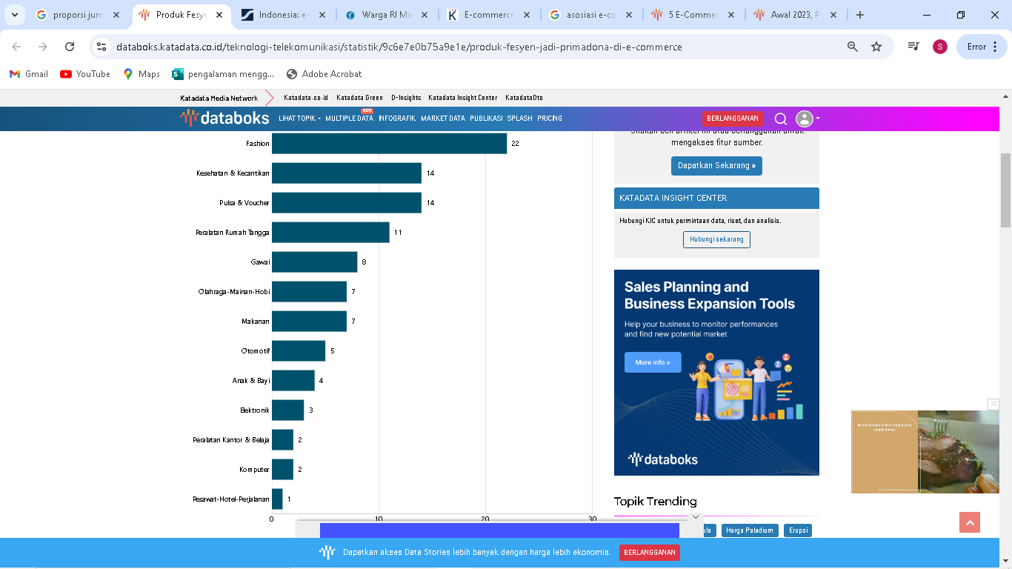
Figure 1. Number of Product Transactions Based on Product Category
Source: https://databoks.katadata.co.id
One of the challenges consumers face when purchasing fashion products online is the inability to try them on before making a purchase, especially for items with specific sizing requirements. Therefore, it's unclear what size is right for them.
As the backbone of digital businesses in Indonesia, these e-commerce companies are also required to maintain operational stability. One common strategy for e-commerce companies to maintain their business is implementing service/administration fees and commissions with partners.
In 2024, e-commerce platforms like Shopee, Lazada, and Tokopedia are expected to continue to be a preferred choice for sellers to promote their products and a convenient way for buyers to purchase products. The following graph shows e-commerce visitor numbers in the first and second quarters of 2023.
Based on the Figure 2, Shopee was the e-commerce site with the most visits in Indonesia in the first quarter of 2023. During the same period, Tokopedia's site averaged 117 million visits, Lazada's site 83.2 million visits, BliBli's site 25.4 million visits, and Bukalapak's site 18.1 million visits per month.
The various conveniences offered by Shopee, including ease of use, stay-at-home options, and affordable prices, have made online shopping increasingly popular. Shopee offers consumers attractive deals, including numerous promotions, convenient payment methods, free shipping, and lower prices. This, in turn, encourages people to purchase products they don't actually need. Table 1 is Shopee user data from 2017 to 2023.
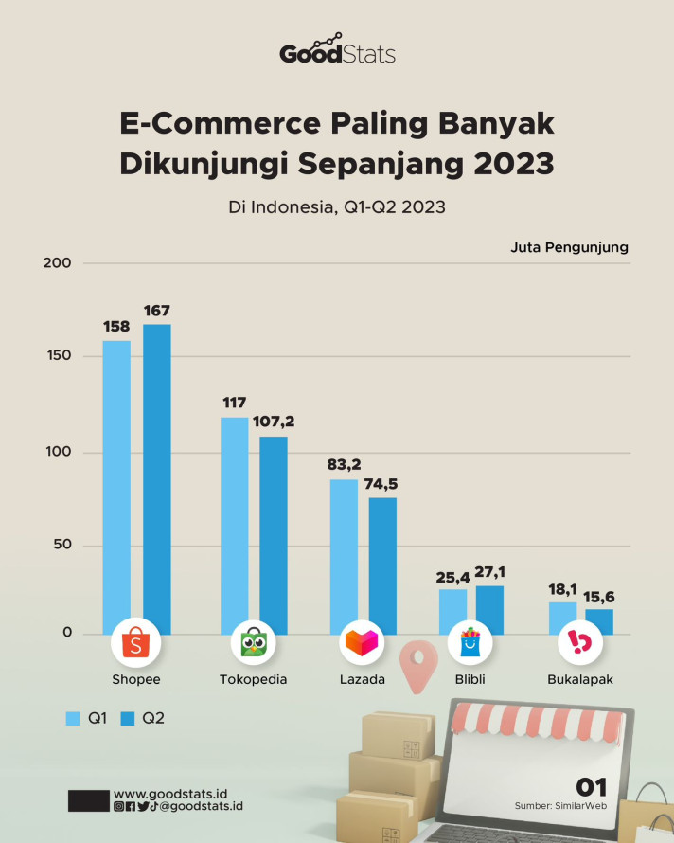
Figure 2. Average Number of E-Commerce Visitors Per Month in the First Quarter of 2023
Source: https://databoks.katadata.co.id

Table 1. Data on the Number of Shopee Users from 2017 to 2023
Year | Number of Users (In Millions)
2017 | 90
2018 | 150
2019 | 200
2020 | 280
2021 | 340
2022 | 270
2023 | 295
Source: https://www.businessofapps.com/data/shopee-statistics
An interesting phenomenon was found: Shopee experienced user fluctuations in 2022. This could be due to several factors, including a decline in consumer purchasing power. The fluctuations in user numbers have driven Shopee to continuously innovate and update. This is done to attract consumer interest, and Shopee continues to see a surge in visitors.
One factor that can influence purchasing decisions is price. For consumers, comparing the same product at different prices is a key consideration when deciding whether to purchase. E-commerce applications make it easier for consumers to find the best price. This is because consumers can view the prices of the products they are searching for and sort them from lowest to highest, allowing them to choose the product they desire (Indah and Dandy, 2022).
Another factor that can influence purchasing decisions is product reviews. Reviews can help customers determine product review criteria and reduce perceived costs when making purchasing decisions. Online product reviews can help customers understand products, establish product review criteria, make informed decisions, and reduce perceived costs when making decisions (Adhitya, 2021).
Promotional factors can also influence purchasing decisions. Internet users process information primarily up to the second level, namely the stage of paying attention to the advertisements they receive. This aligns with the purchasing decision process, which also only reaches the stage of internet users paying attention to the advertisements they receive, by clicking on the advertisement to obtain further information, allowing consumers to make a purchasing decision (Mujiyana and Elissa, 2023).
Several researchers have conducted research on the factors influencing purchasing decisions. The results of these previous studies differ and are inconsistent. Table 2 summarize the research gaps identified.
Table 2. Research Gap
Research Gap | Research result | Researchers
There is a difference  the influence of prices on  buying decision | Price has a positive and significant influence on purchasing decisions | (Jauhari and Kurnia, 2022)  (Liana and Nawawi, 2023)
 | Price has no effect on purchasing decisions | (Adhitya, 2021)
There is a difference  the influence of product reviews on  buying decision | Product reviews have a positive and significant influence on purchasing decisions | (Adhitya, 2021)  (Edy and Haryanti, 2024)
 | Product reviews have no influence on purchasing decisions | (Sari, Syskadiana, 2019)  (Lestari, et al., 2023)
There is a difference  the influence of promotion on  buying decision | Promotion has a positive and significant influence on purchasing decisions | (Mujiyana, and Elissa, 2023)  (Liana and Nawawi, 2023)
 | Promotions have no effect on purchasing decisions | (Setyagustina et al., 2022)  (Alfitoch, 2022)
Source: Various Research Sources

LITERATURE REVIEW
Buying decision
According to Tjiptono (2019), a purchasing decision is a process of recognizing a problem by a consumer, followed by searching for information about a particular product or brand that is considered to be able to solve the problem and evaluating it first, which then leads to a purchasing decision. According to Kotler & Keller (2021), there are four indicators of a purchasing decision, namely: Consistency in a product, Habits in buying products, Recommendations to others, Repeat purchases.
Price
Price is any monetary cost incurred by consumers to obtain a product. Companies must initially set a selling price when developing a new product. Pricing can be problematic because pricing decisions are complex and require consideration of various influencing factors (Adhitya, 2021). Price indicators include the following (Jauhari and Kurnia, 2022): Price affordability, Price commensurate with product quality, Price competitiveness, Price commensurate with product benefits.

Product Reviews
According to Syarifah & Karyaningsih (2021), product reviews are a form of assessment given by previous consumers based on information from product assessments in various aspects, so that consumers can determine the quality of a product. These online customer reviews contain both positive and negative things about the product or company (seller) and are made by consumers via the internet. According to Riyanjaya and Andarini (2022), the indicators of online customer reviews are as follows: source credibility, argument quality, review valance, perceived usefulness, quantity of reviews.

Promotion
According to Satriadi et al. (2021:93–94), Promotion is a communication activity carried out by the owner of a product or service provided to the public with the aim of making the product or service, company name, and brand known to the public and at the same time influencing the public to use the service or product. According to Rangkuti in (Anwar et al., 2022) the indicators used in online sales promotions are Offering something for free, Providing coupons or discounts or other special offers, Providing programs related to loyalty programs, providing programs related to lotteries.

Price on Purchasing Decisions
Price is one of the determining factors for buyers in making purchasing decisions for a product or service. Especially when the products and services being purchased are daily necessities such as food, beverages, and other basic necessities, buyers will pay close attention to the price. Entrepreneurs need to pay attention to this because in business competition, competitors' prices can be lower for the same or even better quality. Therefore, when determining the price of a product or service, both large and small companies must consider their buyers and competitors (Mantara and Yulianthini, 2021). Research conducted by previous researchers Indah and Dandy (2022) and Liana and Nawawi (2023) indicates that price has a positive and significant effect on purchasing decisions. Therefore, the following hypothesis can be drawn:
H₁ : Price influences purchasing decisions

Product Reviews on Purchasing Decisions
According to Syarifah & Karyaningsih (2021), an online customer review is a form of assessment given by previous consumers based on information from product assessments in various aspects, so that consumers can determine the quality of a product. These online customer reviews contain both positive and negative things about the product or company (seller) and are created by consumers via the internet and describe the characteristics (e.g., advantages and disadvantages) of a product. Positive product reviews can make consumers who want to buy a product more confident that the product is worth buying. Negative product reviews will make other consumers hesitate and tend to reduce their intention to buy the product. The results of research conducted by previous researchers Adhitya (2021) and Edy and Haryanti (2024) stated that the product review variable has a positive and significant effect on purchasing decisions. Therefore, the following hypothesis can be drawn. The hypothesis for this study is based on the description above, namely:
H ₂ : Product reviews influence purchasing decisions

Promotion of Purchasing Decisions
According to Marlina (2018), promotion is a set of activities intended to influence customers. Sales promotions can be an effective means of persuading customers to purchase a particular product. Promotion is the process of introducing a product to the public. Effective and attractive promotions will attract consumers and make them decide to purchase the product. Research conducted by previous researchers Liana and Nawawi (2023) and Pratiwi et al. (2023) found that promotional variables have a positive and significant effect on purchasing decisions. Therefore, the following hypothesis can be drawn:
H ₃ : Promotion influences product purchasing decisions
Figure 3 represents the conceptual framework of this research, which analyzes the influence of Price (X1), Product Reviews (X2), and Promotion (X3) on Purchasing Decisions (Y). The relationship between these variables is tested using three main hypotheses: H1, H2, and H3. All of these elements are systematically arranged to form a comprehensive picture within the research conceptual framework.

RESEARCH METHODS
This research is included in the quantitative research category. The object used in this study is the people in Semarang City who buy fashion products through the Shopee application. The population in this study is the people in Semarang City who buy fashion products through the Shopee application. The sampling technique used in this study is purposive sampling. The considerations for determining the sample are the use of respondents aged over 17 years, have shopped for fashion products in the Shopee marketplace, Semarang City residents. The sampling technique refers to using the Cochran formula and obtained a sample size of 97 respondents. Data collection techniques can be done by questionnaire methods, interview methods and documentation. The tests include validity tests, reliability tests, classical assumption tests, determination coefficient tests, F tests, t tests, and analysis techniques using multiple linear regression analysis.

Price (X₁)
Product Reviews (X₂)
Promotion (X₃)
Purchasing Decisions (Y)
H₁
H₂
H₃
Figure 3. Research Concept Framework

RESULTS AND DISCUSSION
Respondent Description
Table 3. Respondent Description
Criteria | Information | Amount | Percentage
Gender | Man | 26 | 26.8%
 | Woman | 71 | 73.2%
Age | 17 – 20 years | 21 | 21.6%
 | 21 - 25 years old | 45 | 46.4%
 | 26 - 30 years old | 14 | 14.4%
 | 31 - 35 years old | 9 | 9.3%
 | 36 - 40 years old | 7 | 7.2%
 | > 40 years | 1 | 1.0%
Work | Students | 46 | 47.4%
 | Government employees | 12 | 12.4%
 | Self-employed | 30 | 30.9%
 | Private employees | 9 | 9.3%
Education | Senior High School | 24 | 24.7%
 | Diploma | 22 | 22.7%
 | S1 | 46 | 47.4%
 | Masters/Doctoral Degree | 5 | 5.2%

Based on the Table 3, it shows that of the 97 respondents, the majority of respondents were female with a total of 71 respondents or 73.2%, while male respondents numbered 26 respondents or 18.75%. These results indicate that respondents who have purchased fashion products from the Shopee e-commerce platform in Semarang City are predominantly female. Based on age, most are between 21 – 25 years old, namely 45 respondents or 46.4%. These results indicate that respondents who have purchased fashion products from the Shopee e-commerce platform in Semarang City are dominated by young people who are very concerned about their appearance in their activities. Based on occupation, most are students, namely 46 respondents or 47.4%. These results indicate that respondents who have purchased fashion products from the Shopee e-commerce platform in Semarang City are predominantly students, where students quickly obtain developing information, especially current fashion trends, so these students often buy fashion products. Based on education, most have a bachelor's degree, namely 46 respondents or 47.4%. These results show that respondents who have purchased fashion products from the Shopee e-commerce platform in Semarang City are dominated by people who are currently pursuing a bachelor's degree or have graduated from a bachelor's degree, with higher education, of course, they will have sufficient knowledge to make purchases.

Testing the Coefficient of Determination (R²)
Table 4 shows that the coefficient of determination, as measured by the adjusted R-square, is 0.793, or 79.3%. This means that the variables of price, environment, and promotion together contribute 79.3% to purchasing decisions. The remaining 20.7% is influenced by other variables not included in the study.
Table 4. R² Test Result
Model | R | R Square | Adjusted R Square | Standard Error of the Estimate
1 | .894 ª | .799 | .793 | 1.024
Source: Processed Primary Data, 2025
F Test
Based on the Table 5, it can be seen that the calculated F = 123.250 and the significance value is 0.000<0.05, which means that price, product reviews and promotions together have a significant influence on purchasing decisions.

Hypothesis Testing
Based on the data processing results in Table 6, it is known that the price variable has a t _{- value} of 4.103, a significance level of 0.000 < 0.05, and a coefficient of 0.273. The meaning of these results is that price has a positive and significant influence on purchasing decisions. Therefore, it can be concluded that hypothesis 1, which states that price influences purchasing decisions, is accepted.
Based on the data processing results in Table 6, it is known that the product review variable has a t-value _{of} 2.454, a significance level of 0.016 < 0.05, and a regression coefficient of 0.122. The meaning of these results is that product reviews have a positive and significant influence on purchasing decisions. Therefore, it can be concluded that hypothesis 2, which states that product reviews influence purchasing decisions, is accepted.
Based on the data processing results in Table 6, it is known that the Promotion variable has a t - value of 6.931, a significance level of 0.000 < 0.05, and a regression coefficient of 0.505. The meaning of these results is that Promotion has a positive and significant influence on purchasing decisions. Therefore, it can be concluded that hypothesis 3, which states that promotion influences purchasing decisions, is accepted.

Discussion
The Influence of Price on Purchasing Decisions
Based on the results of the hypothesis 1 test, it shows that price has a positive and significant influence on purchasing decisions. The better the consumer's perception of the offered price, the higher the purchasing decision. According to Kotler and Armstrong in Mantara and Yulianthini (2021), price can be narrowly defined as the amount of money charged for a product or service. Price in this study uses indicators of price affordability, price suitability to product quality, price competitiveness, and price suitability to product benefits . Products that have affordable prices, prices comparable to product quality, prices lower than other stores, prices that match the product's benefits, will make consumers decide to buy the product. The results of this study are supported by research conducted by Indah and Dandy (2022) and Liana and Nawawi, (2023), which state that the price variable has a positive and significant influence on purchasing decisions.
Table 5. F Test Results
Model |  | Sum of Squares | df | Mean Square | F | Sig.
1 | Regression | 388.064 | 3 | 129.355 | 123.250 | .000 ª
1 | Residual | 97.606 | 93 | 1.050
1 | Total | 485.670 | 96
Source: Processed Primary Data, 2025
Table 6. Hypothesis Test Results
Model |  | Unstandardized Coefficients |  | Standardized Coefficients | t | Sig.
 |  | B | Std. Error | Beta
1 | (Constant) | .784 | .822 |  | .955 | .342
1 | Price (X1) | .273 | .067 | .271 | 4.103 | .000
1 | Product Reviews (X2) | .122 | .050 | .183 | 2,454 | .016
1 | Promotion (X3) | .505 | .073 | .533 | 6,931 | .000
Source: Processed Primary Data, 2025
The Influence of Product Reviews on Purchasing Decisions
Based on the results of hypothesis 2 testing, it shows that product reviews has a significant positive influence on purchasing decisions. The better the product reviews the higher the purchasing decision. Likewise, vice versa, the worse the product reviews The lower the purchasing decision. Product reviews in this study include source credibility, argument quality, review valence, perceived usefulness, and quantity of reviews. A good product review is one that comes from a credible source, contains positive statements about the product being reviewed, provides benefits, and has a high number of reviews. Good reviews will convince potential consumers to purchase a product, especially fashion products sold on Shopee. The results of this study are supported by research conducted by Adhitya (2021) and Edy and Haryanti (2024), which states that product review variables have a positive and significant influence on purchasing decisions.

The Effect of Promotion on Purchasing Decisions
Based on the results of the hypothesis 3 test, it shows that promotion has a significant positive influence on purchasing decisions. The higher the promotion the higher the purchasing decision. Likewise, vice versa, the lower the promotion The lower the purchasing decision. According to Marlina (2018), promotion is defined as a set of activities intended to influence customers. Sales promotions can be an effective means of persuading customers to purchase a particular product. Promotion is the process of introducing a product to the public. Effective and attractive promotions will attract consumers and make them decide to purchase the product. Promotions in this study include additional free offers, coupons or purchase discounts, programs related to loyalty programs, programs related to sweepstakes, games, and various games with winners determined. Increasingly attractive promotional programs will attract potential consumers to purchase fashion products on Shopee. The results of this study are supported by the results of research conducted by previous researchers Liana and Nawawi (2023) and Pratiwi et al., (2023) who stated that promotional variables have a positive and significant effect on purchasing decisions.

CONCLUSION
Based on the results of the analysis of the factors that influence online purchasing decisions for fashion products on Shopee in the Semarang City community, it can be concluded that the results of testing hypothesis 1 obtained a significance of 0.000 <0.05, so that hypothesis 1 is accepted, price has a positive and significant influence on purchasing decisions. The better the consumer's perception of the price offered, the higher the purchasing decision. The results of testing hypothesis 2 obtained a significance of 0.016 <0.05, so that hypothesis 2 is accepted, product reviews has a significant positive influence on purchasing decisions. The better the product reviews the higher the purchasing decision. Likewise, vice versa, the worse the product reviews then the lower the purchasing decision. The results of testing hypothesis 3 obtained a significance of 0.000 <0.05, so hypothesis 3 is accepted, promotion has a positive and significant influence on purchasing decisions. The higher the promotion the higher the purchasing decision. Likewise, vice versa, the lower the promotion the lower the purchasing decision will be.
Suggestions could include additional variables that could influence purchasing decisions, such as product quality, product variety, or seller responsiveness. Increasing the number of respondents is necessary to ensure that the research results are more representative of actual consumers. Further research can also expand the research area, not only in Semarang City but also in other major cities. Price variables have a significant influence on purchasing decisions and must always receive attention from the store. The set price must always consider its suitability to the quality of the product offered, the set price must also be competitive with those offered by other e-commerce. Product review variables also have a significant influence on purchasing decisions. Therefore, to get good product reviews, detailed explanations are needed that are in accordance with the product offered, without exaggerating the product description so that buyers will be satisfied if they receive goods that match the description of the item. Thus, it is hoped that the product will receive positive reviews. Promotion is also a variable that has a significant positive influence on purchasing decisions. Promotions must always be carried out regularly, so that potential consumers do not miss the promotion. Continuous promotions can attract more potential consumers to be interested in purchasing the product.

REFERENCES
Adhitya, Wisnu Rayhan. (2021). Analysis of Factors Influencing Online Purchasing Decisions of Students in Medan City on the Shopee Application. Accumulated Journal, 3(2). 142-161.
Alfitoch, Ulfi Ansyah. (2022). The influence of advertisements, free shipping promotions, and discounts on purchasing decisions on online shopping applications (Residents of RT 8, Karangbesuki Village, Malang City). Jurnal Ilmiah Riset Manajemen, 11(12), 71-78.
Amelia I, R, and Mahfudz. (2022). The Influence of Customer Reviews and Marketing Events on Customer Satisfaction with Impulse Buying as an Intervening Variable (A Study of Shopee Users in Semarang City). Diponegoro Journal of Management. 11(6), 1-6.
Amirullah. (2021). Principles of Marketing Management, Compiled According to the Semester Learning Plan. Sidoarjo: Indomedia Pustaka.
Anwar, MK, Kurniati, RR, Kristianto, D. (2022). The Influence of Online Promotion and Price Perception on Purchasing Decisions (A Study at the Sport Station Dinoyo Shoe Store, Malang). Thesis. Islamic University of Malang.
Ardianti, and W. Widiartanto, (2019). The Influence of Online Customer Reviews and Online Customer Ratings on Purchasing Decisions through the Shopee Marketplace. (A Study on Active Students of the Faculty of Social and Political Sciences, Diponegoro University. Journal of Business Administration, 8(2), 55-66.
Edy Irwan C, and Haryanti Setyani S. (2024). The Effect of Customer Reviews on Impulsive Buying at Tik Tok Stores (Study Generation Z in Indonesia). Indonesian Journal of Business Analytics (IJBA),.4(4), 1296-1317.
Gina Eka Putri (2021). Factors Influencing Online Fashion Product Purchasing Decisions Through E-Commerce. Proceedings of the Fashion Culinary Engineering Education Program. Yogyakarta.
Ikhsan, M, F, and Sitohang, F, M, (2021). The Influence of Product Quality, Price, and Service Quality on Purchasing Decisions of Angkasa Bodywork Services. Journal of Management Science and Research.
Jauhari and Kurnia. (2022). Factors influencing the decision to purchase fashion products online through e-commerce applications among the millennial generation in Jakarta. Jurnal JUKIM, 3(4), 122-127.
Kotler, & Keller. (2021). Marketing Management Essentials. Andi Publisher.
Kotler and Keller. (2019). Consumer Behavior. Bandung: PT. Remaja Rosdakarya.
Liana, Vega and Nawawi, Z, M. (2023). Factors Influencing Fashion Product Purchasing Decisions on Shopee: A Case Study of UIN North Sumatra Students. Journal of Management & Business, 2(20), 214-224. https://doi.org/10.47467/manbiz.v2i2.1881.
Lestari, et al. (2023). The Influence of Online Customer Review, Online Customer Rating, and Price Consciousness on Purchasing Decisions: A Study of TikTok Shop Customers in Yogyakarta City. Journal of Islamic Economics, Finance & Business, 5(6), 2358-2368. https://doi.org/10.47467/alkharaj.v5i6.2306.
Mangkunegara, A, A, P., AEP, G. (2019). Consumer Behavior (6th Edition). Bandung: PT Refika Aditama.
Mantara, Made Abi, and Yulianthini (2022). Factors Determining Online Purchasing Decisions on Bukalapak among Students of the Faculty of Economics, Undiksha. Prospek: Journal of Management and Business, 4(2), 2685-5526.
Marlina, Siti. (2018). Analysis of the Influence of Product Quality, Promotion, Brand Trust, and Consumer Satisfaction on Purchasing Decisions of Honda Vario Motorcycles (Study on Honda Vario Motorcycle Users in Muara Bulian District). Scientific Journal of Batanghari Jambi University,18 (1), 20-28.
Mujiyana, and Elissa (2023). Analysis of Factors Influencing Internet Purchasing Decisions in Online Stores. J@TI Undip, VIII(3), 20-27.
Nugraha, J, et al. (2021). Consumer Behavior Theory. Pekalongan. PT. Nasya. Expanding Management
Prabarini, A., Heryanto, B., & Astutik, P. (2019). The Influence of Sales Promotions and Discounts on Consumer Purchasing Decisions at Borobudur Department Store, Kediri (Case Study of Wardah Beauty Products). JIMEK: Scientific Journal of Economics Students, 1(2), 259.
Pratiwi, D., Hermawati, A., & Kurniawati, D. (2023). The Influence of Content Marketing, Influencers, and Free Shipping on Consumer Purchase Interest in Fashion Products on TikTok. Jimp, 3(1), 1–11.
Riyanjaya, N, A, and Andarini, S. (2022). The Influence of Online Customer Reviews and Online Customer Ratings on Purchase Interest of Wardah Products on the Online Shopping Site Shopee. Journal of Economic Studies, 3(5), 909-926. Httsp://doi.org/1047467/elmal.v3i5.1179.
Satriadi et al. (2021). Marketing Management. Yogyakarta: Samudra Biru. (Member of IKAPI)
Sari, Syskadiana (2019). The Influence of Reference Groups, Online Customer Reviews, and Brand Image on Purchase Intention and Purchase Decisions. Thesis, Muhammadiyah University of Magelang.
Setyagustina, K., Rahmania, R., Joni, M., Kholik, A., & Suhitasari, WD (2022). The Effect of Discounts, Free Shipping, and COD Systems on Online Shopping Interest in the Shopee Application from an Islamic Economic Perspective. Jurnal Economina, 1(3), 596–607. https://doi.org/10.55681/economina.v1i3.149
Situmorang, MK (2021). The Influence of Consumer Behavior on the Use of Electronic Money (Digital Wallets) as a Payment Tool during the Covid-19 Pandemic in Medan City, Maneggio: Scientific Journal of Master of Management, 4(1), 123–130.
Sunyoto, Danang. (2019). Fundamentals of Marketing Management (Concepts, Strategies, and Cases). 3rd Edition. Jakarta: PT. Buku Seru.
Syarifah, E., & Karyaningsih, K. (2021). The Influence of Online Customer Reviews and Trust on Purchase Intention in the Lazada Marketplace. YUME: Journal of Management, 4(1).
Tjiptono, Fandy. (2019). Customer Satisfaction - Concept, Measurement, and Strategy. Yogyakarta: Andi Offset.pp.21-136
Ulhab Nafidal et.al. (2022). The Influence of Online Customer Reviews and Online Customer Ratings on Purchasing Decisions Through the Shopee Marketplace (A Case Study of the Community in Bolo District, Bima Regency). Educational & Economic Studies, 5(2), 2614-6002.

