Lampiran 5. Gambar Identifikasi Senyawa Dengan KLT (Ekstrak)
- Di Bawah Sinar UV 254 nm dan Penampak Bercak
UV 254 nm | Penampak Bercak | Perhitungan Rf
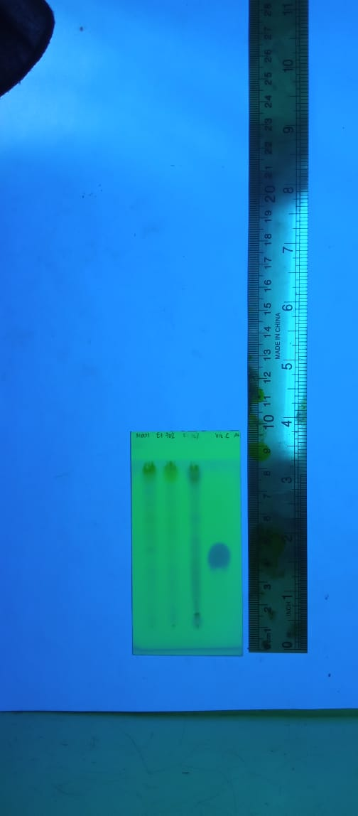  (a) (b) (c) (d)  - Uji Kualitatif DPPH | 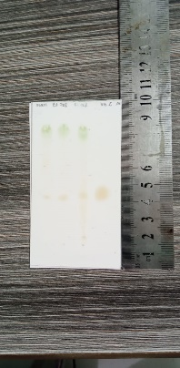  Uji Kualitatif DPPH | Rf (Noda Kuning Pucat)
  Sampel | Hitung | Rf
  (a) MetOH | 3,3 cm / 8 cm | 0,41
  (b) Et70 | 3,3 cm / 8 cm | 0,41
  (c) Et96 | 3,3 cm / 8 cm | 0,41
  (d) Vit C | 3,4 cm / 8 cm | 0,42
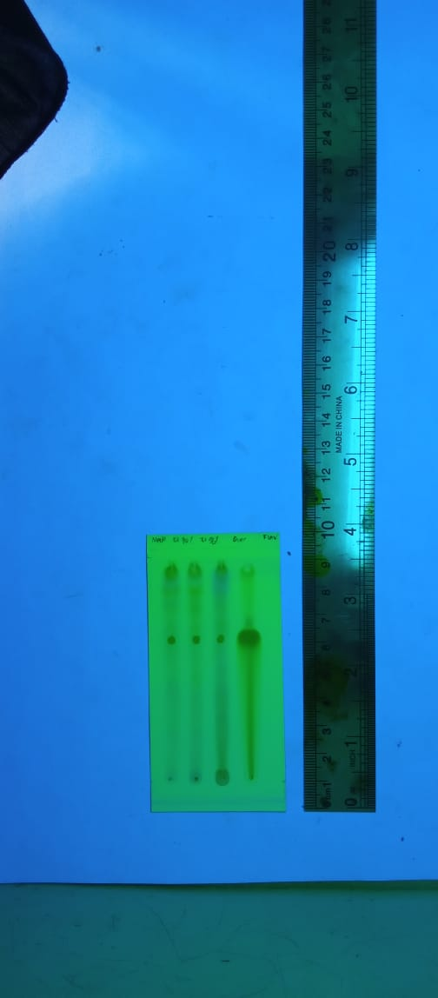  - Flavonoid | 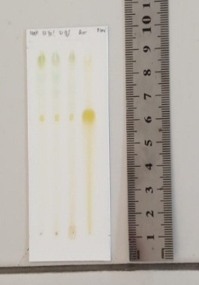  Flavonoid | Rf (Noda Kuning)
  Sampel | Hitung | Rf
  (a) MetOH | 5,0 cm / 8 cm | 0,36
  (b) Et70 | 5,0 cm / 8 cm | 0,36
  (c) Et96 | 5,0 cm / 8 cm | 0,36
  (d)Quersetin | 5,0 cm / 8 cm | 0,36
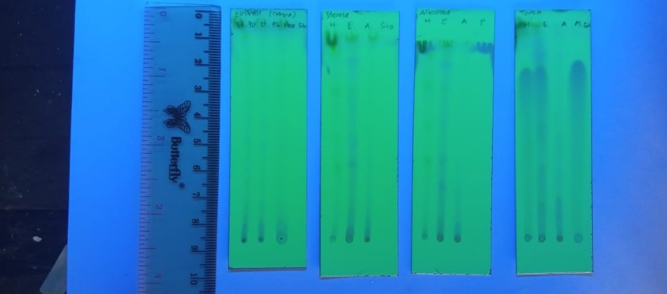  - Steroid | 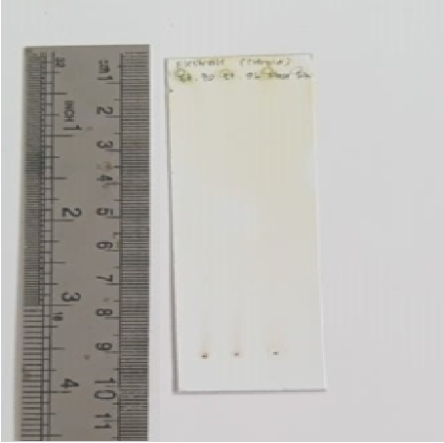  Steroid | Rf (Putih latar coklat cepat hilang)
  Sampel | Hitung | Rf
  (a) MetOH | 8,0 cm /9,0 cm | 0,88
  (b) Et70 | 8,0 cm /9,0 cm | 0,88
  (c) Et96 | 8,0 cm /9,0 cm | 0,88
  (d) Sitosterol | 8,0 cm /9,0 cm | 0,88
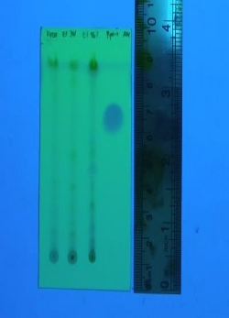  - Alkaloid | 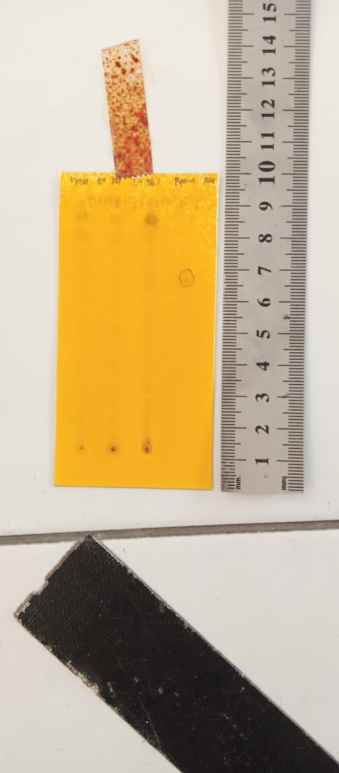  Alkaloid | Rf (Coklat)
  Sampel | Hitung | Rf
  (a) MetOH | - | -
  (b) Et70 | - | -
  (c) Et96 | - | -
  (d) Piperin | 5,9 cm / 8 cm | 0,74
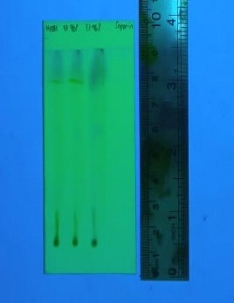  - Saponin | 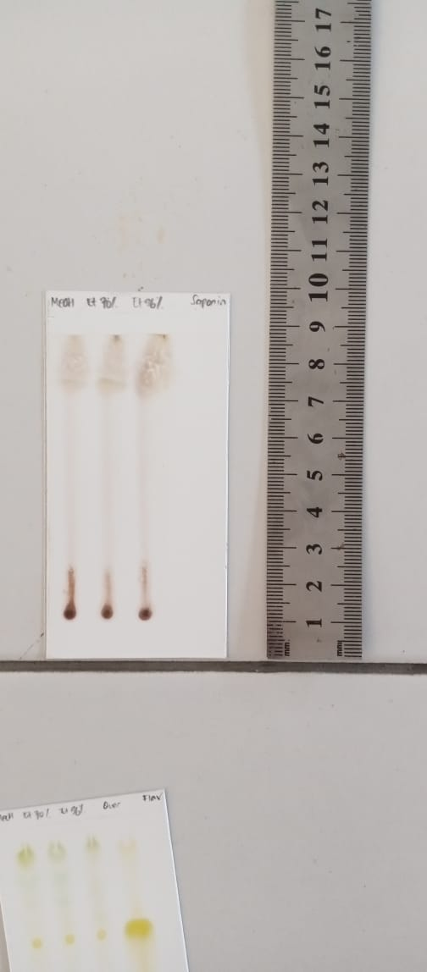  Saponin | Rf (Merah Ungu)
  Sampel | Hitung | Rf
  (a) MetOH | 7,0 cm / 8 cm | 0,88
  (b) Et70 | 7,0 cm / 8 cm | 0,88
  (c) Et96 | 7,0 cm / 8 cm | 0,88
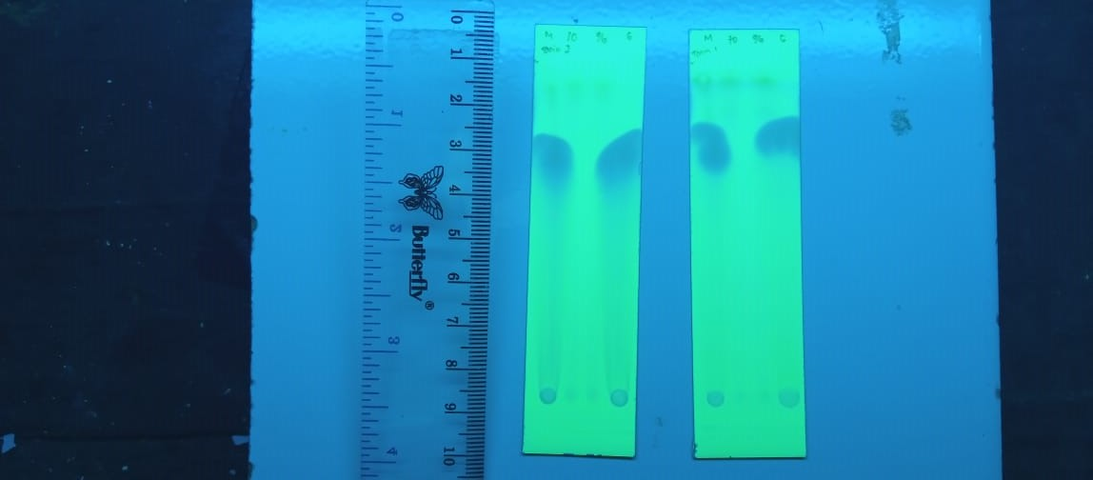  - Tanin | 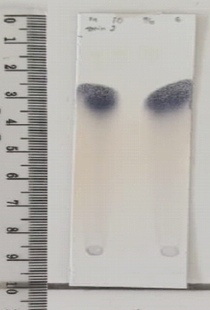  Tanin | Rf (Biru Kehitaman)
  Sampel | Hitung | Rf
  (a) MetOH | 5,5 / 8 cm | 0,69
  (b) Et70 | - | -
  (c) Et96 | - | -
  (d) Asam Galat | 5,5 / 8 cm | 0,69

Lampiran 6. Gambar Preparasi Uji Antioksidan Ekstrak
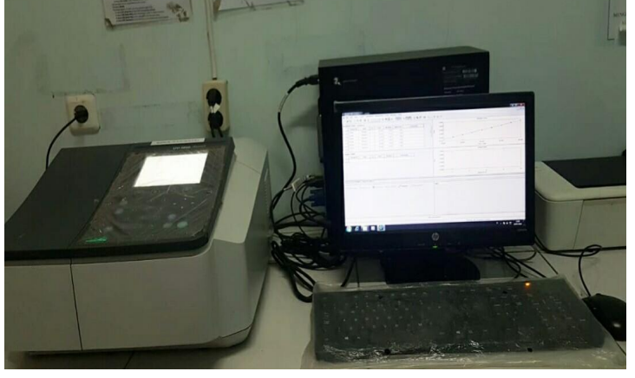  Spektrofotometer UV – Vis (Shimadzu Series 1700) | 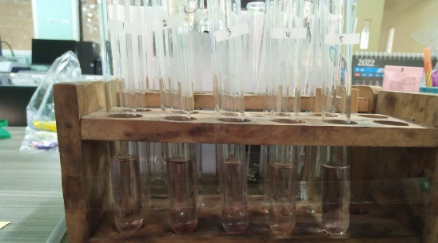  DPPH + deret Vit C
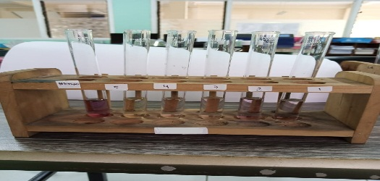  DPPH + deret MeOH | 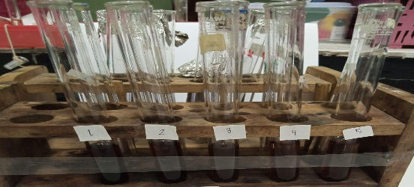  DPPH + deret Et70
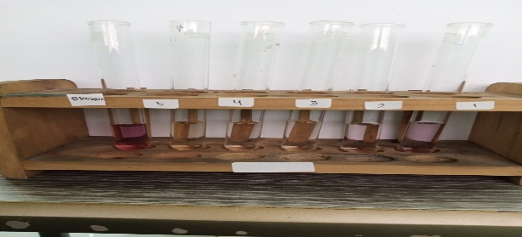
DPPH + deret Et96

Lampiran 7. Hasil Uji Antioksidan Ekstrak Daun Kawista
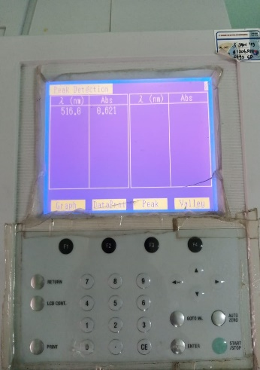  λmaks | 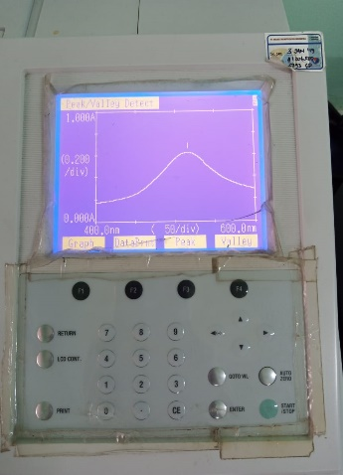  Spektrum DPPH | Hasil absorbansi
  Konsentrasi | Abs | λmaks
  100 ppm | 0,621 | 516 nm

- Antioksidan Ekstrak Metanol Daun Kawista

Penimbangan Baku Induk MeOH Replikasi I :
50,3 mg ad 50 ml = 1006 ppm
P. 5kali = 201,2 ppm
Deret Konsentrasi  (V1 x C1 = V2 x C2) | Koreksi Kadar  (V1 x C1 = V2 x C2)
20 ppm  V1 x 1000 ppm = 50 ml x 20 ppm  V1 = 1 ml | 20 ppm  1 ml x 1002 ppm = 50 ml x C2  C2 = 20,04 ppm
80 ppm  V1 x 200 ppm = 25 ml x 80 ppm  V1 = 10 ml | 80 ppm  10 ml x 201,2 ppm = 25 ml x C2  C2 = 80,48 ppm
100 ppm  V1 x 200 ppm = 10 ml x 100 ppm  V1 = 5 ml | 100 ppm  5 ml x 201,2 ppm = 10 ml x C2  C2 = 100,60 ppm
120 ppm  V1 x 200 ppm = 5 ml x 120 ppm  V1 = 3 ml | 120 ppm  3 ml x 201,2 ppm = 5 ml x C2  C2 = 120,72 ppm
140 ppm  V1 x 200 ppm = 5 ml x 140 ppm  V1 = 3,5 ml | 140 ppm  3,5 ml x 201,2 ppm = 5 ml x C2  C2 = 140,84 ppm

Penimbangan Baku Induk MeOH Replikasi II :
48,9 mg ad 50 ml = 978 ppm
P. 5kali = 195,6 ppm
Deret Konsentrasi  (V1 x C1 = V2 x C2) | Koreksi Kadar  (V1 x C1 = V2 x C2)
60 ppm  V1 x 200 ppm = 10 ml x 60 ppm  V1 = 3 ml | 60 ppm  3 ml x 195,6 ppm = 10 ml x C2  C2 = 58,68 ppm
80 ppm  V1 x 200 ppm = 25 ml x 80 ppm  V1 = 10 ml | 80 ppm  10 ml x 195,6 ppm = 25 ml x C2  C2 = 78,24 ppm
100 ppm  V1 x 200 ppm = 10 ml x 100 ppm  V1 = 5 ml | 100 ppm  5 ml x 195,6 ppm = 10 ml x C2  C2 = 97,80 ppm
120 ppm  V1 x 200 ppm = 5 ml x 120 ppm  V1 = 3 ml | 120 ppm  3 ml x 195,6 ppm = 5 ml x C2  C2 = 117,36 ppm
140 ppm  V1 x 200 ppm = 5 ml x 140 ppm  V1 = 3,5 ml | 140 ppm  3,5 ml x 195,6 ppm = 5 ml x C2  C2 = 136,92 ppm

Penimbangan Baku Induk MeOH Replikasi III :
49,7 mg ad 50 ml = 994 ppm
P. 5kali = 198,8 ppm
Deret Konsentrasi  (V1 x C1 = V2 x C2) | Koreksi Kadar  (V1 x C1 = V2 x C2)
60 ppm  V1 x 200 ppm = 10 ml x 60 ppm  V1 = 3 ml | 60 ppm  3 ml x 198,8 ppm = 10 ml x C2  C2 = 59,64 ppm
80 ppm  V1 x 200 ppm = 25 ml x 80 ppm  V1 = 10 ml | 80 ppm  10 ml x 198,8 ppm = 25 ml x C2  C2 = 79,52 ppm
100 ppm  V1 x 200 ppm = 10 ml x 100 ppm  V1 = 5 ml | 100 ppm  5 ml x 198,8 ppm = 10 ml x C2  C2 = 99,40 ppm
120 ppm  V1 x 200 ppm = 5 ml x 120 ppm  V1 = 3 ml | 120 ppm  3 ml x 198,8 ppm = 5 ml x C2  C2 = 119,28 ppm
140 ppm  V1 x 200 ppm = 5 ml x 140 ppm  V1 = 3,5 ml | 140 ppm  3,5 ml x 198,8 ppm = 5 ml x C2  C2 = 139,16 ppm

- Persen Inhibisi DPPH dan Regresi Linier
Rumus % inhibisi = $\frac{ (Abs Kontrol-Abs Sampel)}{Abs Kontrol}$ x 100%
Replikasi | Konsentrasi Sampel (ppm)  (X) | Absorbansi Kontrol | Absorbansi Sampel | % Inhibisi  (Y) | Regresi Linier | Nilai IC₅₀  (ppm) | Nilai AAI
I | 60,360 | 0,621 | 0,333 | 46,38 | a = 33,1240 | 77,2372 | 1,2947
I | 80,480 | 0,621 | 0,301 | 51,53 | b = 0,2185 | 77,2372 | 1,2947
I | 100,600 | 0,621 | 0,288 | 53,62 | r = 0,99218 | 77,2372 | 1,2947
I | 120,720 | 0,621 | 0,250 | 59,74 | r = 0,99218 | 77,2372 | 1,2947
I | 140,840 | 0,621 | 0,222 | 64,25 | r = 0,99218 | 77,2372 | 1,2947
II | 58,680 | 0,621 | 0,342 | 44,93 | a = 28,7930 | 82,5658 | 1,2112
II | 78,240 | 0,621 | 0,316 | 49,11 | b = 0,2569 | 82,5658 | 1,2112
II | 97,800 | 0,621 | 0,297 | 52,17 | r = 0,9809 | 82,5658 | 1,2112
II | 117,360 | 0,621 | 0,264 | 57,49 | r = 0,9809 | 82,5658 | 1,2112
II | 136,920 | 0,621 | 0,212 | 65,86 | r = 0,9809 | 82,5658 | 1,2112
III | 59,640 | 0,621 | 0,350 | 43,64 | a = 29,9517 | 82,5020 | 1,2121
III | 79,520 | 0,621 | 0,308 | 50,40 | b = 0,2430 | 82,5020 | 1,2121
III | 99,400 | 0,621 | 0,286 | 53,95 | r = 0,9956 | 82,5020 | 1,2121
III | 119,280 | 0,621 | 0,254 | 59,10 | r = 0,9956 | 82,5020 | 1,2121
III | 139,160 | 0,621 | 0,227 | 63,45 | r = 0,9956 | 82,5020 | 1,2121
Rata – rata ± SD |  |  |  |  |  | 82,2034 ± 0,5733 | 1,2165 ± 0,00852

- Antioksidan Ekstrak Etanol 70% Daun Kawista
Penimbangan Baku Induk Et70 Replikasi I :
50,3 mg ad 50 ml = 1006 ppm
P. 5kali = 201,2 ppm
Deret Konsentrasi  (V1 x C1 = V2 x C2) | Koreksi Kadar  (V1 x C1 = V2 x C2)
60 ppm  V1 x 200 ppm = 10 ml x 60 ppm  V1 = 3 ml | 60 ppm  3 ml x 201,2 ppm = 10 ml x C2  C2 = 60,36 ppm
80 ppm  V1 x 200 ppm = 25 ml x 80 ppm  V1 = 10 ml | 80 ppm  10 ml x 201,2 ppm = 25 ml x C2  C2 = 80,48 ppm
100 ppm  V1 x 200 ppm = 10 ml x 100 ppm  V1 = 5 ml | 100 ppm  5 ml x 201,2 ppm = 10 ml x C2  C2 = 100,60 ppm
120 ppm  V1 x 200 ppm = 5 ml x 120 ppm  V1 = 3 ml | 120 ppm  3 ml x 201,2 ppm = 5 ml x C2  C2 = 120,72 ppm
140 ppm  V1 x 200 ppm = 5 ml x 140 ppm  V1 = 3,5 ml | 140 ppm  3,5 ml x 201,2 ppm = 5 ml x C2  C2 = 140,84 ppm

Penimbangan Baku Induk Et70 Replikasi II :
50,6 mg ad 50 ml = 1012 ppm
P. 5kali = 202,4 ppm
Deret Konsentrasi  (V1 x C1 = V2 x C2) | Koreksi Kadar  (V1 x C1 = V2 x C2)
60 ppm  V1 x 200 ppm = 10 ml x 60 ppm  V1 = 3 ml | 60 ppm  3 ml x 202,4 ppm = 10 ml x C2  C2 = 60,72 ppm
80 ppm  V1 x 200 ppm = 25 ml x 80 ppm  V1 = 10 ml | 80 ppm  10 ml x 202,4 ppm = 25 ml x C2  C2 = 80,96 ppm
100 ppm  V1 x 200 ppm = 10 ml x 100 ppm  V1 = 5 ml | 100 ppm  5 ml x 202,4 ppm = 10 ml x C2  C2 = 101,20 ppm
120 ppm  V1 x 200 ppm = 5 ml x 120 ppm  V1 = 3 ml | 120 ppm  3 ml x 202,4 ppm = 5 ml x C2  C2 = 121,44 ppm
140 ppm  V1 x 200 ppm = 5 ml x 140 ppm  V1 = 3,5 ml | 140 ppm  3,5 ml x 202,4 ppm = 5 ml x C2  C2 = 141,68 ppm

Penimbangan Baku Induk Et70 Replikasi III :
49,9 mg ad 50 ml = 988 ppm
P. 5kali = 199,6 ppm
Deret Konsentrasi  (V1 x C1 = V2 x C2) | Koreksi Kadar  (V1 x C1 = V2 x C2)
60 ppm  V1 x 200 ppm = 10 ml x 60 ppm  V1 = 3 ml | 60 ppm  3 ml x 199,6 ppm = 10 ml x C2  C2 = 59,88 ppm
80 ppm  V1 x 200 ppm = 25 ml x 80 ppm  V1 = 10 ml | 80 ppm  10 ml x 199,6 ppm = 25 ml x C2  C2 = 79,84 ppm
100 ppm  V1 x 200 ppm = 10 ml x 100 ppm  V1 = 5 ml | 100 ppm  5 ml x 199,6 ppm = 10 ml x C2  C2 = 99,80 ppm
120 ppm  V1 x 200 ppm = 5 ml x 120 ppm  V1 = 3 ml | 120 ppm  3 ml x 199,6 ppm = 5 ml x C2  C2 = 119,76 ppm
140 ppm  V1 x 200 ppm = 5 ml x 140 ppm  V1 = 3,5 ml | 140 ppm  3,5 ml x 199,6 ppm = 5 ml x C2  C2 = 139,72 ppm
- Persen Inhibisi DPPH dan Regresi Linier
Rumus % inhibisi = $\frac{ (Abs Kontrol-Abs Sampel)}{Abs Kontrol}$ x 100%
Replikasi | Konsentrasi Sampel (ppm)  (X) | Absorbansi Kontrol | Absorbansi Sampel | % Inhibisi  (Y) | Regresi Linier | Nilai IC₅₀  (ppm) | Nilai AAI
I | 60,360 | 0,621 | 0,410 | 33,98 | a = 18,2287 | 143,829 | 0,6953
I | 80,480 | 0,621 | 0,407 | 34,46 | b = 0,2209 | 143,829 | 0,6953
I | 100,600 | 0,621 | 0,384 | 38,16 | r = 0,95924 | 143,829 | 0,6953
I | 120,720 | 0,621 | 0,345 | 44,44 | r = 0,95924 | 143,829 | 0,6953
I | 140,840 | 0,621 | 0,303 | 51,21 | r = 0,95924 | 143,829 | 0,6953
II | 60,720 | 0,621 | 0,420 | 32,37 | a = 13,0274 | 131,775 | 0,7589
II | 80,960 | 0,621 | 0,415 | 33,17 | b = 0,28244 | 131,775 | 0,7589
II | 101,200 | 0,621 | 0,367 | 40,90 | r = 0,97989 | 131,775 | 0,7589
II | 121,440 | 0,621 | 0,322 | 48,15 | r = 0,97989 | 131,775 | 0,7589
II | 141,68 | 0,621 | 0,289 | 53,46 | r = 0,97989 | 131,775 | 0,7589
III | 59,88 | 0,621 | 0,412 | 33,66 | a = 17,6812 | 130,904 | 0,7639
III | 79,84 | 0,621 | 0,398 | 35,91 | b = 0,24526 | 130,904 | 0,7639
III | 99,80 | 0,621 | 0,366 | 41,06 | r = 0,98793 | 130,904 | 0,7639
III | 119,76 | 0,621 | 0,322 | 48,15 | r = 0,98793 | 130,904 | 0,7639
III | 139,72 | 0,621 | 0,298 | 52,01 | r = 0,98793 | 130,904 | 0,7639
Rata – rata ± SD |  |  |  |  |  | 135,5030 ± 7,2238 | 0,7934 ± 0,0382

- Antioksidan Ekstrak Etanol 96% Daun Kawista
Penimbangan Baku Induk Et96 Replikasi I :
49,9 mg ad 50 ml = 988 ppm
P. 5kali = 199,6 ppm
Deret Konsentrasi  (V1 x C1 = V2 x C2) | Koreksi Kadar  (V1 x C1 = V2 x C2)
60 ppm  V1 x 200 ppm = 10 ml x 60 ppm  V1 = 3 ml | 60 ppm  3 ml x 199,6 ppm = 10 ml x C2  C2 = 59,88 ppm
80 ppm  V1 x 200 ppm = 25 ml x 80 ppm  V1 = 10 ml | 80 ppm  10 ml x 199,6 ppm = 25 ml x C2  C2 = 79,84 ppm
100 ppm  V1 x 200 ppm = 10 ml x 100 ppm  V1 = 5 ml | 100 ppm  5 ml x 199,6 ppm = 10 ml x C2  C2 = 99,80 ppm
120 ppm  V1 x 200 ppm = 5 ml x 120 ppm  V1 = 3 ml | 120 ppm  3 ml x 199,6 ppm = 5 ml x C2  C2 = 119,76 ppm
140 ppm  V1 x 200 ppm = 5 ml x 140 ppm  V1 = 3,5 ml | 140 ppm  3,5 ml x 199,6 ppm = 5 ml x C2  C2 = 139,72 ppm

Penimbangan Baku Induk Et96 Replikasi II :
50,5 mg ad 50 ml = 1010 ppm
P. 5kali = 202 ppm
Deret Konsentrasi  (V1 x C1 = V2 x C2) | Koreksi Kadar  (V1 x C1 = V2 x C2)
60 ppm  V1 x 200 ppm = 10 ml x 60 ppm  V1 = 3 ml | 60 ppm  3 ml x 202 ppm = 10 ml x C2  C2 = 59,88 ppm
80 ppm  V1 x 200 ppm = 25 ml x 80 ppm  V1 = 10 ml | 80 ppm  10 ml x 202 ppm = 25 ml x C2  C2 = 80,80 ppm
100 ppm  V1 x 200 ppm = 10 ml x 100 ppm  V1 = 5 ml | 100 ppm  5 ml x 202 ppm = 10 ml x C2  C2 = 101,00 ppm
120 ppm  V1 x 200 ppm = 5 ml x 120 ppm  V1 = 3 ml | 120 ppm  3 ml x 202 ppm = 5 ml x C2  C2 = 121,20 ppm
140 ppm  V1 x 200 ppm = 5 ml x 140 ppm  V1 = 3,5 ml | 140 ppm  3,5 ml x 202 ppm = 5 ml x C2  C2 = 141,40 ppm

Penimbangan Baku Induk Et96 Replikasi II :
51 mg ad 50 ml = 1020 ppm
P. 5kali = 204 ppm
Deret Konsentrasi  (V1 x C1 = V2 x C2) | Koreksi Kadar  (V1 x C1 = V2 x C2)
60 ppm  V1 x 200 ppm = 10 ml x 60 ppm  V1 = 3 ml | 60 ppm  3 ml x 204 ppm = 10 ml x C2  C2 = 61,20 ppm
80 ppm  V1 x 200 ppm = 25 ml x 80 ppm  V1 = 10 ml | 80 ppm  10 ml x 204 ppm = 25 ml x C2  C2 = 81,60 ppm
100 ppm  V1 x 200 ppm = 10 ml x 100 ppm  V1 = 5 ml | 100 ppm  5 ml x 204 ppm = 10 ml x C2  C2 = 102,00 ppm
120 ppm  V1 x 200 ppm = 5 ml x 120 ppm  V1 = 3 ml | 120 ppm  3 ml x 204 ppm = 5 ml x C2  C2 = 122,40 ppm
140 ppm  V1 x 200 ppm = 5 ml x 140 ppm  V1 = 3,5 ml | 140 ppm  3,5 ml x 204 ppm = 5 ml x C2  C2 = 142,80 ppm

- Persen Inhibisi DPPH dan Regresi Linier
Rumus % inhibisi = $\frac{ (Abs Kontrol-Abs Sampel)}{Abs Kontrol}$ x 100%
Replikasi | Konsentrasi Sampel (ppm)  (X) | Absorbansi Kontrol | Absorbansi Sampel | % Inhibisi  (Y) | Regresi Linier | Nilai IC₅₀  (ppm) | Nilai AAI
I | 59,88 | 0,621 | 0,365 | 41,22 | a = 31,127 | 123,77 | 0,8079
I | 79,84 | 0,621 | 0,357 | 42,51 | b = 0,1525 | 123,77 | 0,8079
I | 99,80 | 0,621 | 0,334 | 46,22 | r = 0,9764 | 123,77 | 0,8079
I | 119,76 | 0,621 | 0,322 | 48,15 | r = 0,9764 | 123,77 | 0,8079
I | 139,72 | 0,621 | 0,288 | 53,62 | r = 0,9764 | 123,77 | 0,8079
II | 60,60 | 0,621 | 0,358 | 42,35 | a = 33,768 | 125,47 | 0,7907
II | 80,80 | 0,621 | 0,347 | 44,12 | b = 0,1283 | 125,47 | 0,7907
II | 101,00 | 0,621 | 0,337 | 45,73 | r = 0,9651 | 125,47 | 0,7907
II | 121,20 | 0,621 | 0,322 | 48,15 | r = 0,9651 | 125,47 | 0,7907
II | 141,40 | 0,621 | 0,290 | 53,30 | r = 0,9651 | 125,47 | 0,7907
III | 61,20 | 0,621 | 0,352 | 43,32 | a = 34,396 | 120,53 | 0,8297
III | 81,60 | 0,621 | 0,348 | 43,96 | b = 0,1295 | 120,53 | 0,8297
III | 102,00 | 0,621 | 0,326 | 47,50 | r = 0,9761 | 120,53 | 0,8297
III | 122,40 | 0,621 | 0,314 | 49,44 | r = 0,9761 | 120,53 | 0,8297
III | 142,80 | 0,621 | 0,287 | 53,78 | r = 0,9761 | 120,53 | 0,8297
Rata – rata ± SD |  |  |  |  |  | 123,5900 ± 2,9718 | 0,8094 ± 0,0195
- Antioksidan Baku Vitamin C
Penimbangan Baku Induk Vit C Replikasi I :
10,2 mg ad 10 ml = 1020 ppm
P. 10kali = 102 ppm
Deret Konsentrasi  (V1 x C1 = V2 x C2) | Koreksi Kadar  (V1 x C1 = V2 x C2)
10 ppm  V1 x 100 ppm = 10 ml x 10 ppm  V1 = 1 ml | 10 ppm  1 ml x 102 ppm = 10 ml x C2  C2 = 10,20 ppm
20 ppm  V1 x 100 ppm = 25 ml x 20 ppm  V1 = 5 ml | 20 ppm  5 ml x 102 ppm = 25 ml x C2  C2 = 20,40 ppm
30 ppm  V1 x 100 ppm = 10 ml x 30 ppm  V1 = 3 ml | 30 ppm  3 ml x 102 ppm = 10 ml x C2  C2 = 30,60 ppm
40 ppm  V1 x 100 ppm = 25 ml x 40 ppm  V1 = 10 ml | 40 ppm  10 ml x 102 ppm = 25 ml x C2  C2 = 40,80 ppm
50 ppm  V1 x 100 ppm = 10 ml x 50 ppm  V1 = 5 ml | 50 ppm  5 ml x 102 ppm = 10 ml x C2  C2 = 51,00 ppm

Penimbangan Baku Induk Vit C Replikasi II :
10 mg ad 10 ml = 1000 ppm
P. 10kali = 100 ppm
Deret Konsentrasi  (V1 x C1 = V2 x C2) | Koreksi Kadar  (V1 x C1 = V2 x C2)
10 ppm  V1 x 100 ppm = 10 ml x 10 ppm  V1 = 1 ml | 10 ppm  1 ml x 100 ppm = 10 ml x C2  C2 = 10,00 ppm
20 ppm  V1 x 100 ppm = 25 ml x 20 ppm  V1 = 5 ml | 20 ppm  5 ml x 100 ppm = 25 ml x C2  C2 = 20,00 ppm
30 ppm  V1 x 100 ppm = 10 ml x 30 ppm  V1 = 3 ml | 30 ppm  3 ml x 100 ppm = 10 ml x C2  C2 = 30,00 ppm
40 ppm  V1 x 100 ppm = 25 ml x 40 ppm  V1 = 10 ml | 40 ppm  10 ml x 100 ppm = 25 ml x C2  C2 = 40,00 ppm
50 ppm  V1 x 100 ppm = 10 ml x 50 ppm  V1 = 5 ml | 50 ppm  5 ml x 100 ppm = 10 ml x C2  C2 = 50,00 ppm

Penimbangan Baku Induk Vit C Replikasi III :
10,4 mg ad 10 ml = 1040 ppm
P. 10kali = 104 ppm
Deret Konsentrasi  (V1 x C1 = V2 x C2) | Koreksi Kadar  (V1 x C1 = V2 x C2)
10 ppm  V1 x 100 ppm = 10 ml x 10 ppm  V1 = 1 ml | 10 ppm  1 ml x 104 ppm = 10 ml x C2  C2 = 10,40 ppm
20 ppm  V1 x 100 ppm = 25 ml x 20 ppm  V1 = 5 ml | 20 ppm  5 ml x 104 ppm = 25 ml x C2  C2 = 20,80 ppm
30 ppm  V1 x 100 ppm = 10 ml x 30 ppm  V1 = 3 ml | 30 ppm  3 ml x 104 ppm = 10 ml x C2  C2 = 31,20 ppm
40 ppm  V1 x 100 ppm = 25 ml x 40 ppm  V1 = 10 ml | 40 ppm  10 ml x 104 ppm = 25 ml x C2  C2 = 41,60 ppm
50 ppm  V1 x 100 ppm = 10 ml x 50 ppm  V1 = 5 ml | 50 ppm  5 ml x 104 ppm = 10 ml x C2  C2 = 52,00 ppm

- Persen Inhibisi DPPH dan Regresi Linier
Rumus % inhibisi = $\frac{ (Abs Kontrol-Abs Sampel)}{Abs Kontrol}$ x 100%
Replikasi | Konsentrasi Sampel (ppm)  (X) | Absorbansi Kontrol | Absorbansi Sampel | % Inhibisi  (Y) | Regresi Linier | Nilai IC₅₀  (ppm) | Nilai AAI
I | 10,20 | 0,621 | 0,323 | 47,99 | a = 43,285 | 15,8709 | 6,3008
I | 20,40 | 0,621 | 0,299 | 51,85 | b = 0,4231 | 15,8709 | 6,3008
I | 30,60 | 0,621 | 0,277 | 55,39 | r = 0,99734 | 15,8709 | 6,3008
I | 40,80 | 0,621 | 0,243 | 60,87 | r = 0,99734 | 15,8709 | 6,3008
I | 51,00 | 0,621 | 0,217 | 65,06 | r = 0,99734 | 15,8709 | 6,3008
II | 10,00 | 0,621 | 0,312 | 49,76 | a = 44,5089 | 13,3203 | 7,5073
II | 20,00 | 0,621 | 0,296 | 52,33 | b = 0,41224 | 13,3203 | 7,5073
II | 30,00 | 0,621 | 0,277 | 55,39 | r = 0,98602 | 13,3203 | 7,5073
II | 40,00 | 0,621 | 0,244 | 60,71 | r = 0,98602 | 13,3203 | 7,5073
II | 50,00 | 0,621 | 0,210 | 66,18 | r = 0,98602 | 13,3203 | 7,5073
III | 10,40 | 0,621 | 0,317 | 48,95 | a = 43,752 | 15,2272 | 6,5672
III | 20,80 | 0,621 | 0,302 | 51,37 | b = 0,41032 | 15,2272 | 6,5672
III | 31,20 | 0,621 | 0,276 | 55,56 | r = 0,98988 | 15,2272 | 6,5672
III | 41,60 | 0,621 | 0,237 | 61,84 | r = 0,98988 | 15,2272 | 6,5672
III | 52,00 | 0,621 | 0,217 | 65,06 | r = 0,98988 | 15,2272 | 6,5672
Rata – rata ± SD |  |  |  |  |  | 14,8061 ± 1,3264 | 6,7918 ± 0,6338

Lampiran 8. Uji Statistika Aktivitas Antioksidan Ekstrak Daun Kawista
- Data IC₅₀ dan AAI Ekstrak Daun Kawista
Kelompok | Replikasi | IC₅₀ | AAI
I  (EM) | 1 | 77,2372 | 1,2947
I  (EM) | 2 | 82,5658 | 1,2112
I  (EM) | 3 | 82,5020 | 1,2121
II  (EE70) | 1 | 143,8290 | 0,6953
II  (EE70) | 2 | 130,9040 | 0,7639
II  (EE70) | 3 | 131,7750 | 0,7589
III  (EE96) | 1 | 123,7700 | 0,8079
III  (EE96) | 2 | 126,4700 | 0,7907
III  (EE96) | 3 | 120,5300 | 0,8297
IV  (SVC) | 1 | 15,8709 | 6,3008
IV  (SVC) | 2 | 13,3203 | 7,5073
IV  (SVC) | 3 | 15,2272 | 6,5672

- Hasil Uji Statistik Antioksidan Ekstrak Daun Kawista
Uji Normalitas
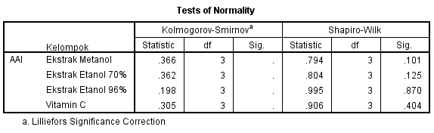
Interpretasi Hasil :
Berdasarkan tabel Test of Normality didapatkan Nilai Sig lebih dari α = 0,05) sehingga H0 diterima dan data antioksidan dinyatakan terdistribusi normal. Sehingga dilanjutkan uji parametrik yaitu Anova one way.

Uji Homogenitas
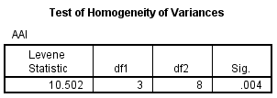
Interpretasi Hasil :
Berdasarkan tabel Test of Homogeneity of Variances didapatkan Sig kurang dari α = 0,05 sehingga H0 ditolak dan data disimpulkan bahwa variasi antar kelompok tidak Homogen.
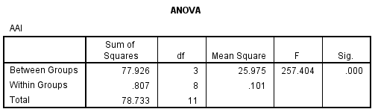
H0 = tidak ada perbedaan signifikan aktivitas antioksidan rata-rata dari masing-masing kelompok.
Ha = ada perbedaan signifikan aktivitas antioksidan rata-rata dari masing-masing kelompok.
Interpretasi Hasil :
Berdasarkan tabel ANOVA didapatkan nilai Sig = 0,000 (Nilai lebih kecil dari α = 0,05) sehingga H0 ditolak dan disimpulkan bahwa terdapat perbedaan signifikan aktivitas antioksidan rata-rata dari masing-masing kelompok.
Uji Pos Hoc
Dikarenakan data disimpulkan homogen maka dilakukan uji pos hoc dengan Equal Variane Not Assumed (Dunnets T3)
