Lampiran 1. Surat keterangan determinasi tanaman kawista

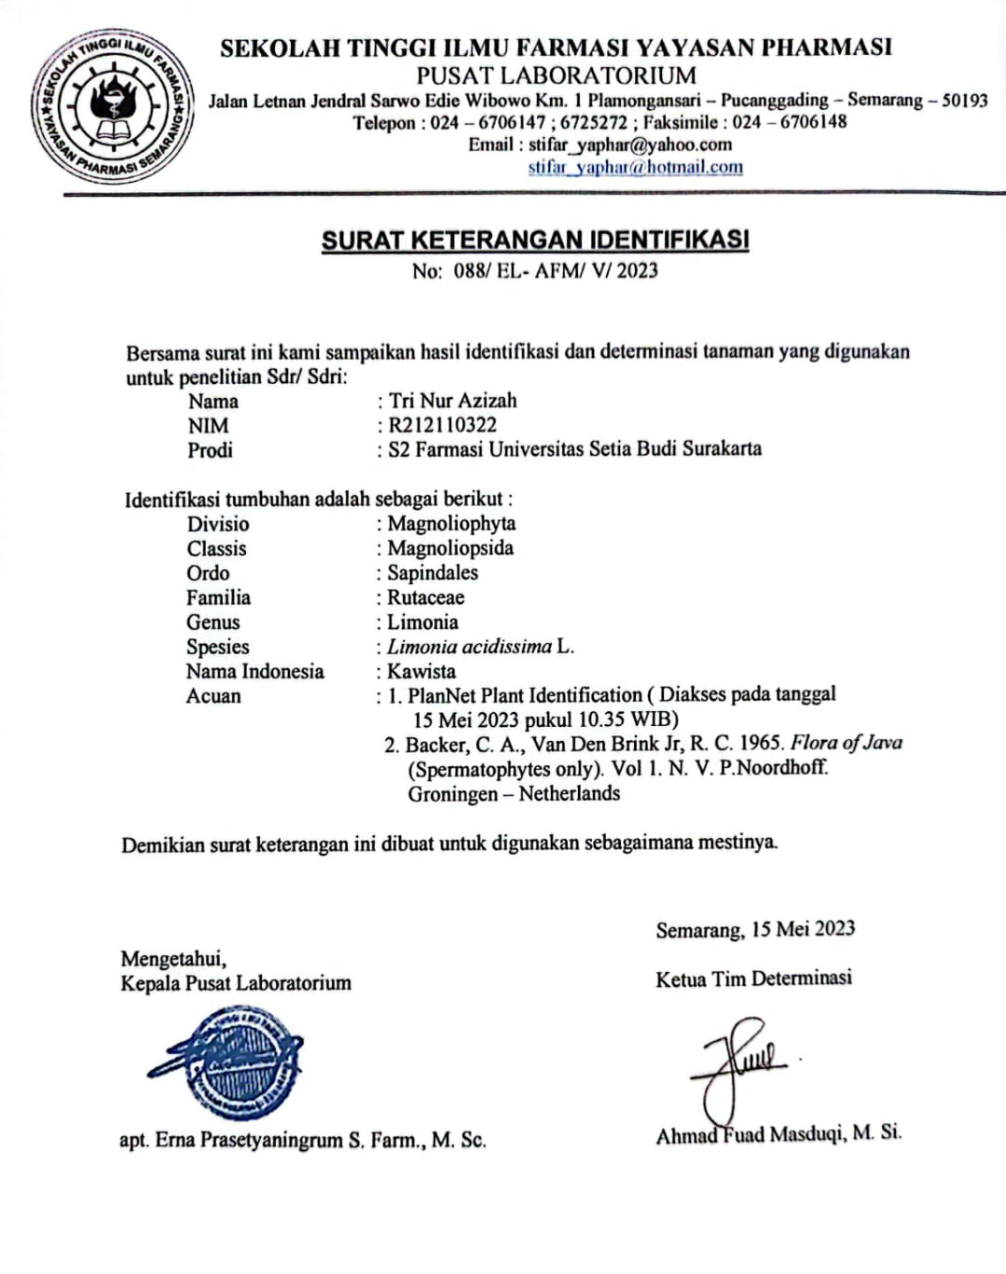

Lampiran 2. Certificate of Analysis Methanol
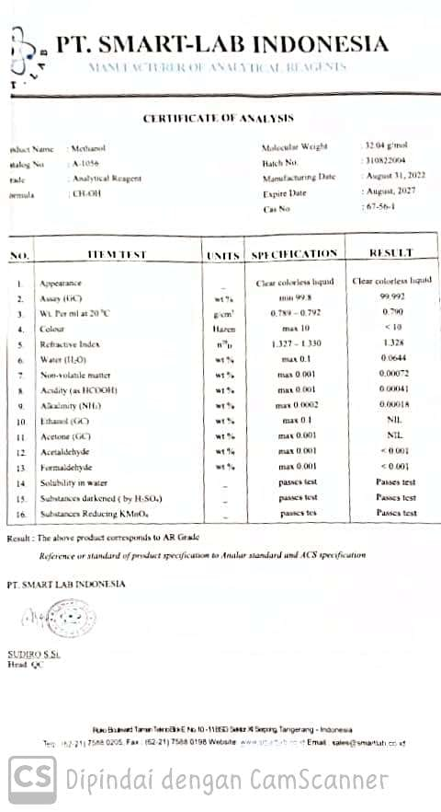
Lampiran 3. Certificate of Analysis DPPH
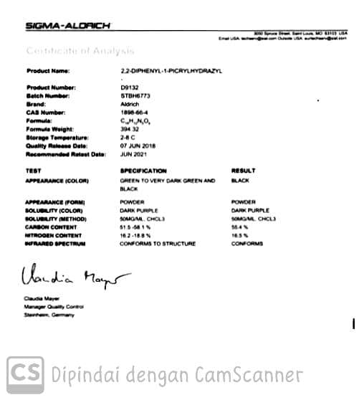
Lampiran 4. Certificate of Analysis Baku Vitamin C
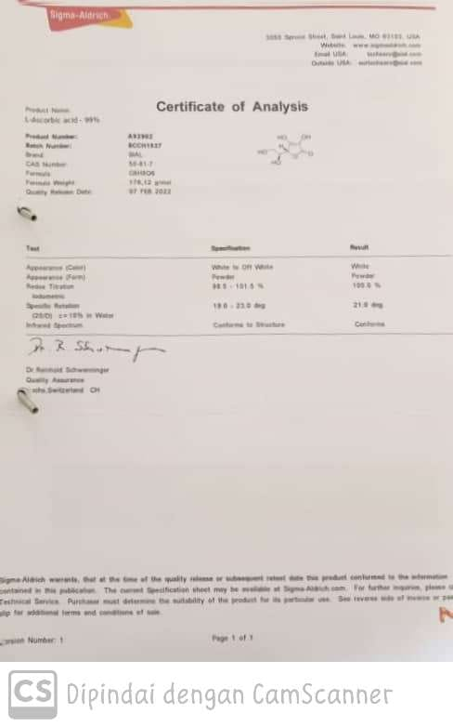
Lampiran 5. Certificate of Analysis KLT
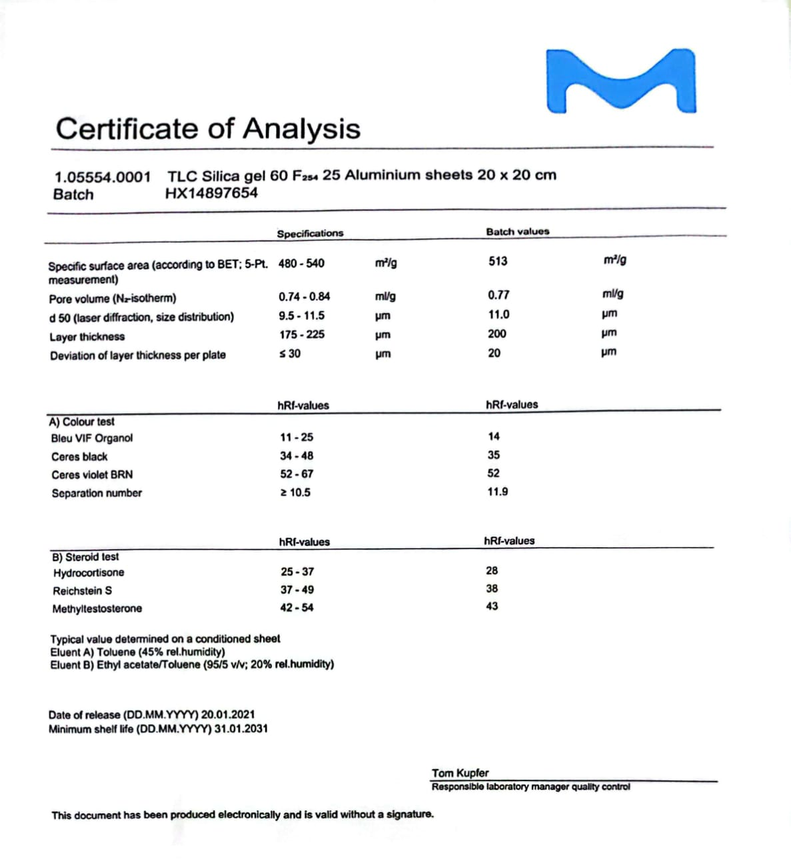

Lampiran 6. Foto Tanaman Daun Kawista dan Serbuk Daun Kawista

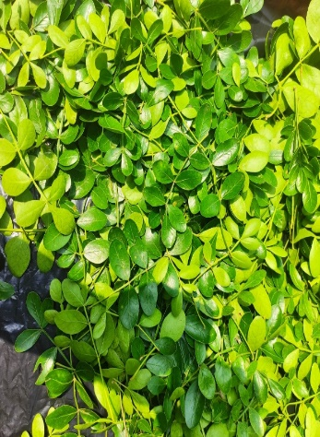  Daun Kawista | 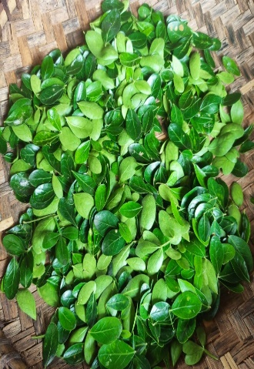  Setelah sortasi basah | 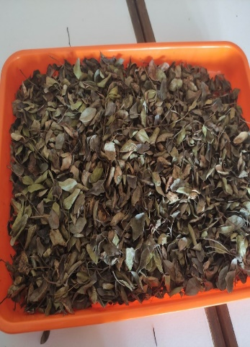  Setelah sortasi kering
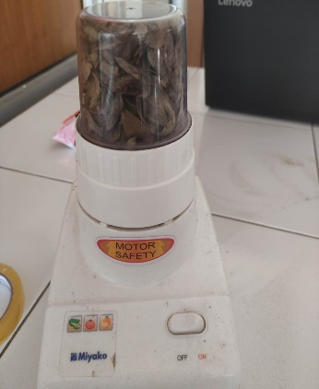  Daun kering diblender | 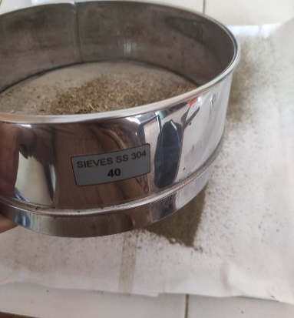  Ayakan mesh 40 | 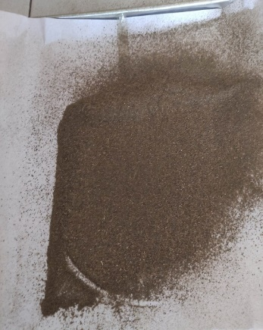  Serbuk Daun Kawista

Lampiran 7. Gambar Preparasi dan Ekstraksi
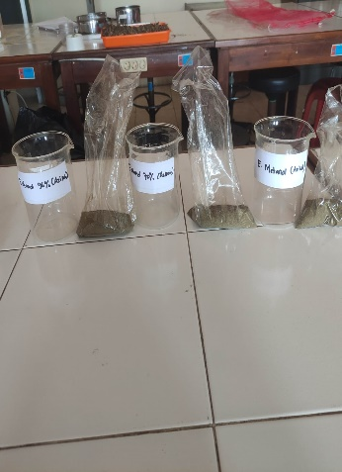  Serbuk 30 gram | 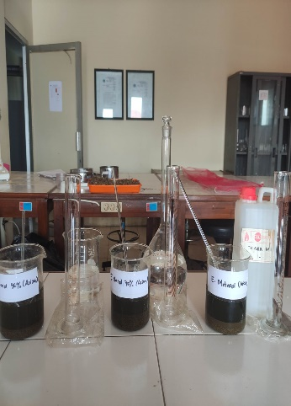  Maserasi 3 Pelarut | 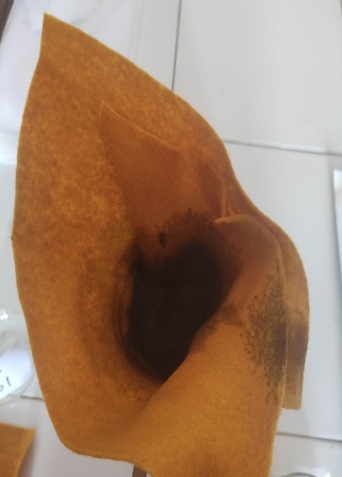  Penyaringan maserat
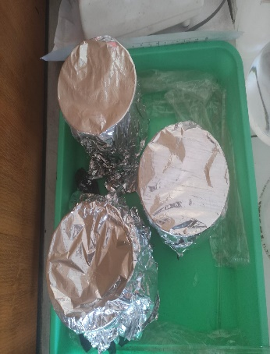  Remaserasi | 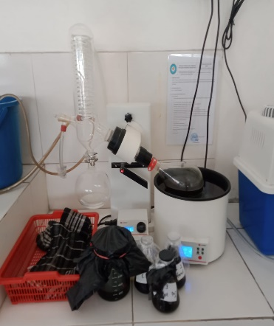  Rotary Evaporator | 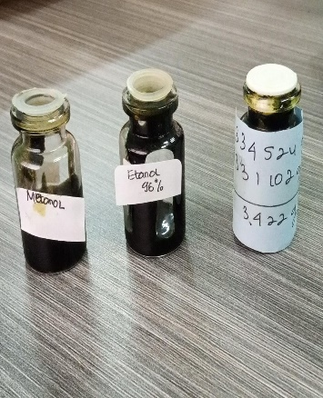  Ekstrak Kental Daun Kawista

Lampiran 8. Perhitungan Rendemen Ekstrak Daun Kawista
Rumus rendemen = $\frac{Berat Ekstrak Kental}{Berat Serbuk} x 100\%$
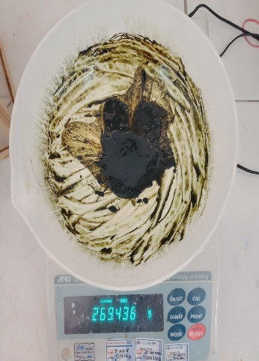  Ekstrak Metanol | 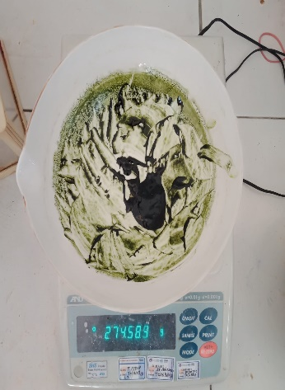  Ekstrak Etanol 70% | 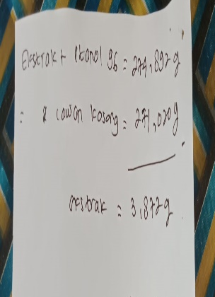  Ekstrak Etanol 96%

- Rendemen Ekstrak Metanol Daun Kawista
Rendemen = $\frac{4,540 gram}{33,6047 gram} x 100\%$ = 13,51 %

- Rendemen Ekstrak Etanol 70% Daun Kawista
Rendemen = $\frac{3,422 gram}{33,0742 gram} x 100\%$ = 10,35 %

- Rendemen Ekstrak Etanol 96% Daun Kawista
Rendemen = $\frac{3,872 gram}{33,5670 gram} x 100\%$ = 11,54 %

Lampiran 9. Gambar Identifikasi Senyawa Dengan KLT
- Penotolan Sampel dan Baku Sebelum di Elusi (UV254)
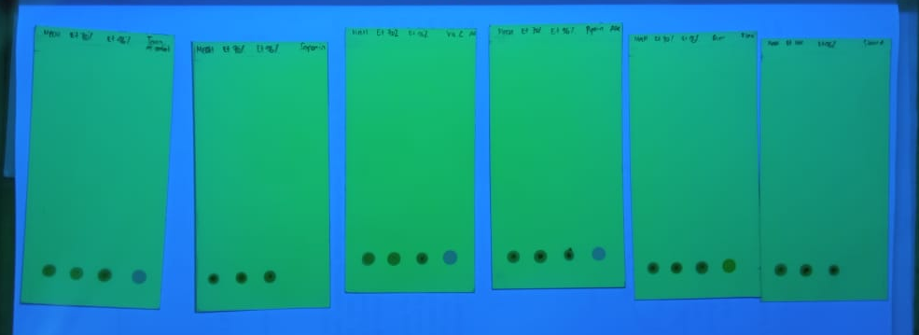
Keterangan :
- Totolan Pertama (MetOH) = Esktrak Metanol Daun Kawista
- Totolan Kedua (Et70) = Esktrak Etanol 70% Daun Kawista
- Totolan Ketiga (Et96) = Esktrak Etanol 96% Daun Kawista
- Totolan Keempat (Baku) = Baku Pembanding

- Di Bawah Sinar UV 254 nm dan Penampak Bercak
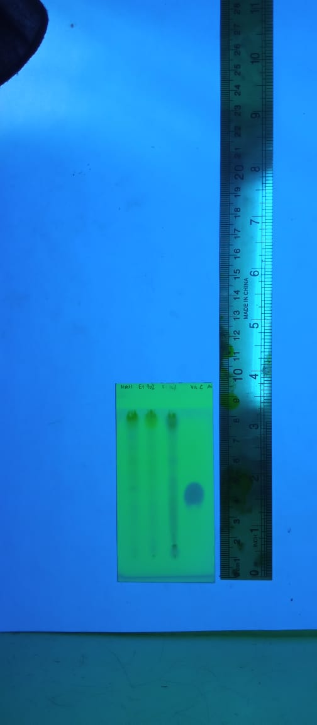  - Uji Kualitatif DPPH | 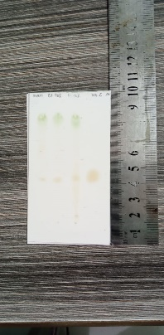  Uji Kualitatif DPPH | Rf (Noda Kuning Pucat)
  Totol | Hitung | Rf
  MetOH | 3,3 cm / 8 cm | 0,41
  Et70 | 3,3 cm / 8 cm | 0,41
  Et96 | 3,3 cm / 8 cm | 0,41
  Vit C | 3,4 cm / 8 cm | 0,42
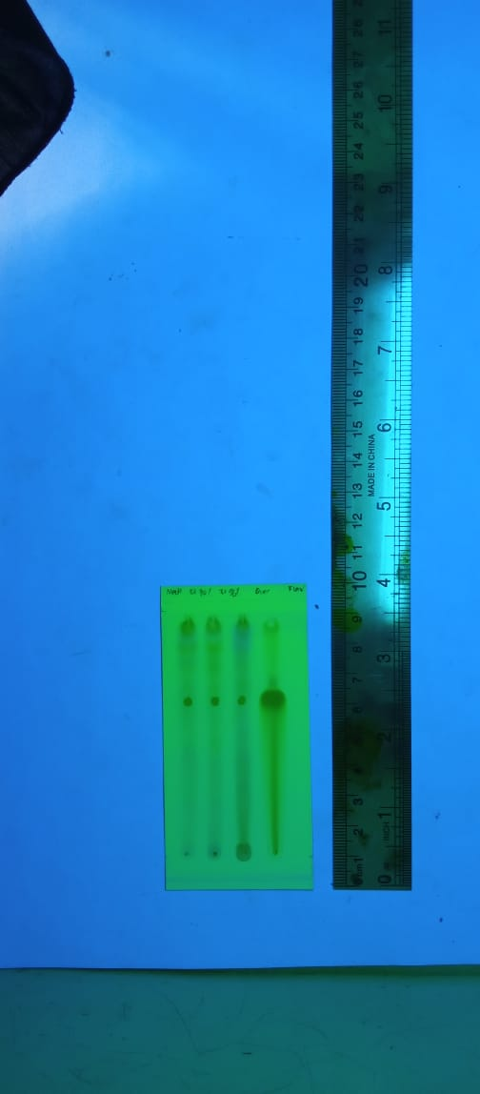  - Flavonoid | 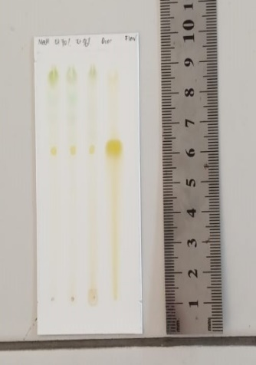Flavonoid | Rf (Noda Kuning)
  Totol | Hitung | Rf
  MetOH | 5,0 cm / 8 cm | 0,36
  Et70 | 5,0 cm / 8 cm | 0,36
  Et96 | 5,0 cm / 8 cm | 0,36
  Quersetin | 5,0 cm / 8 cm | 0,36
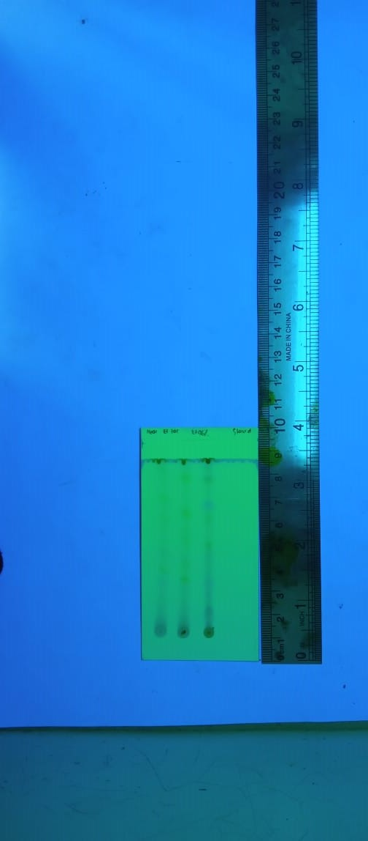  - Steroid | 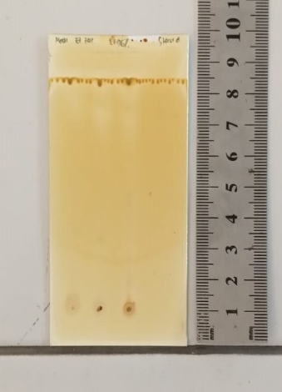  Steroid | Rf (Noda Hijau)
  Totol | Hitung | Rf
  MetOH | - | -
  Et70 | - | -
  Et96 | - | -

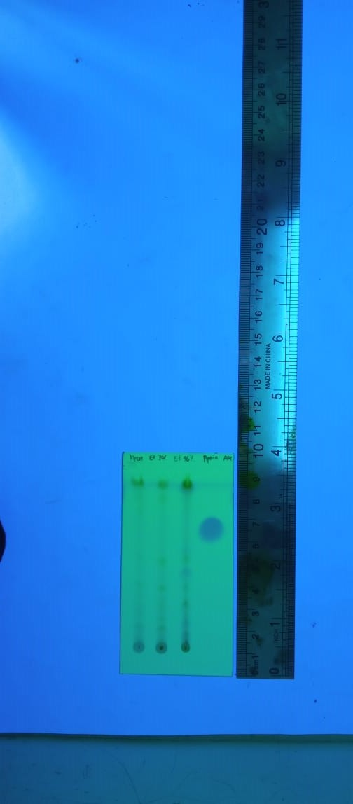  - Alkaloid | 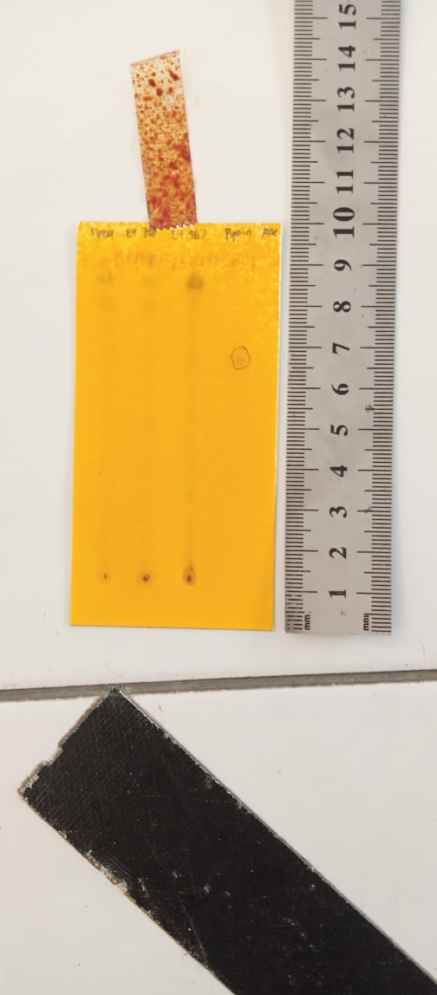  Alkaloid | Rf (Coklat)
  Totol | Hitung | Rf
  MetOH | - | -
  Et70 | - | -
  Et96 | - | -
  Piperin | 5,9 cm / 8 cm | 0,74
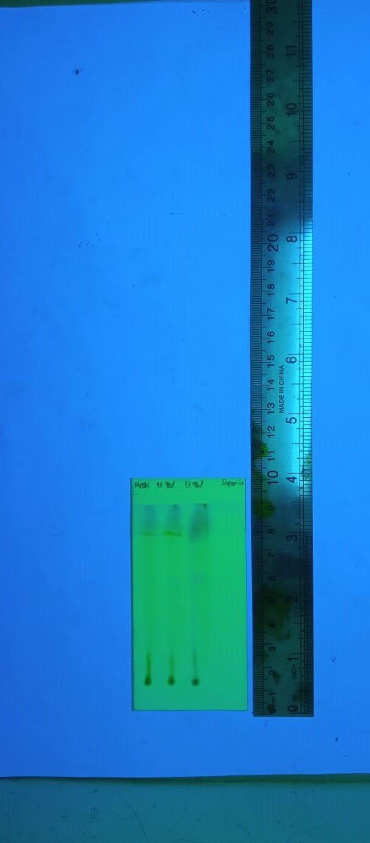  - Saponin | 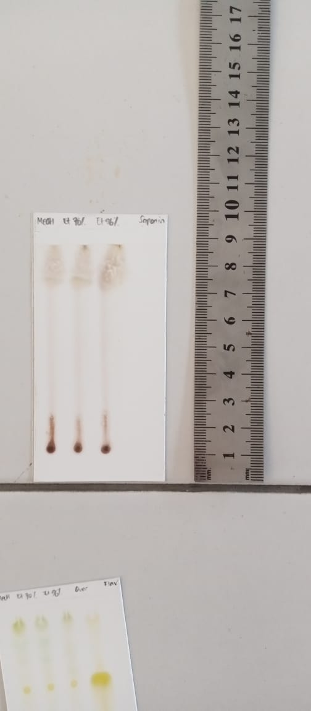  Saponin | Rf (Merah Ungu)
  Totol | Hitung | Rf
  MetOH | 7,0 cm / 8 cm | 0,88
  Et70 | 7,0 cm / 8 cm | 0,88
  Et96 | 7,0 cm / 8 cm | 0,88
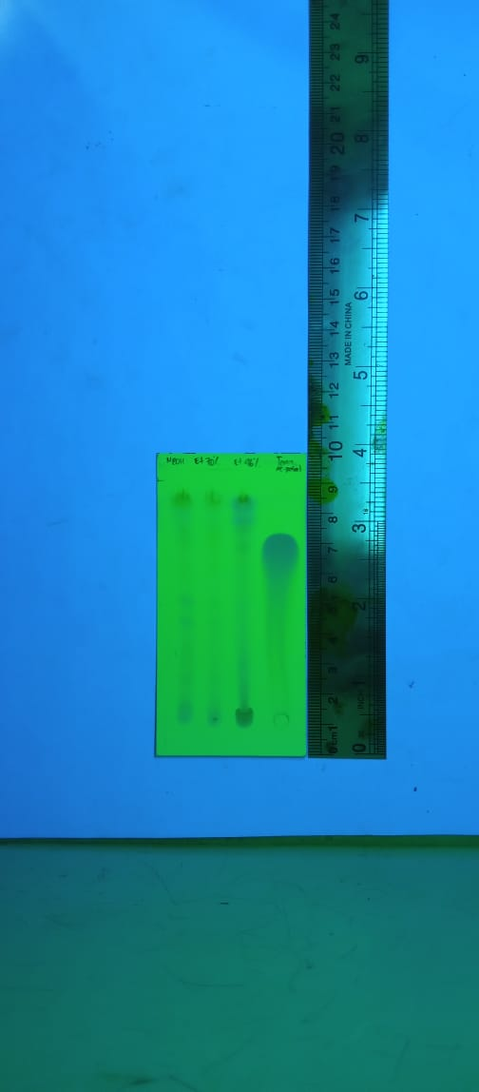  - Tanin | 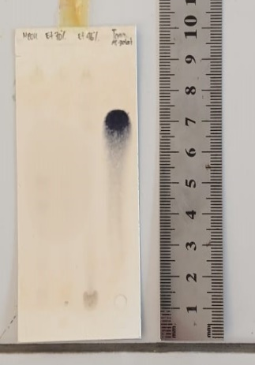  Tanin | Rf (Biru Kehitaman)
  Totol | Hitung | Rf
  MetOH | - | -
  Et70 | - | -
  Et96 | - | -
  Asam Galat | 6,0 cm / 8 cm | 0,75

Lampiran 10. Gambar Preparasi Uji Antioksidan
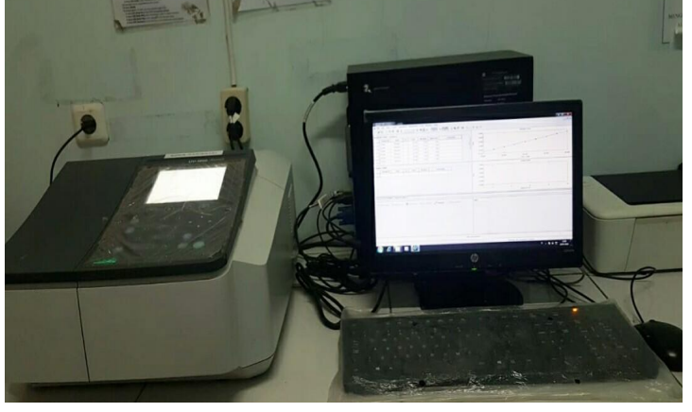
Spektrofotometer UV – Vis (Shimadzu Series 1700)
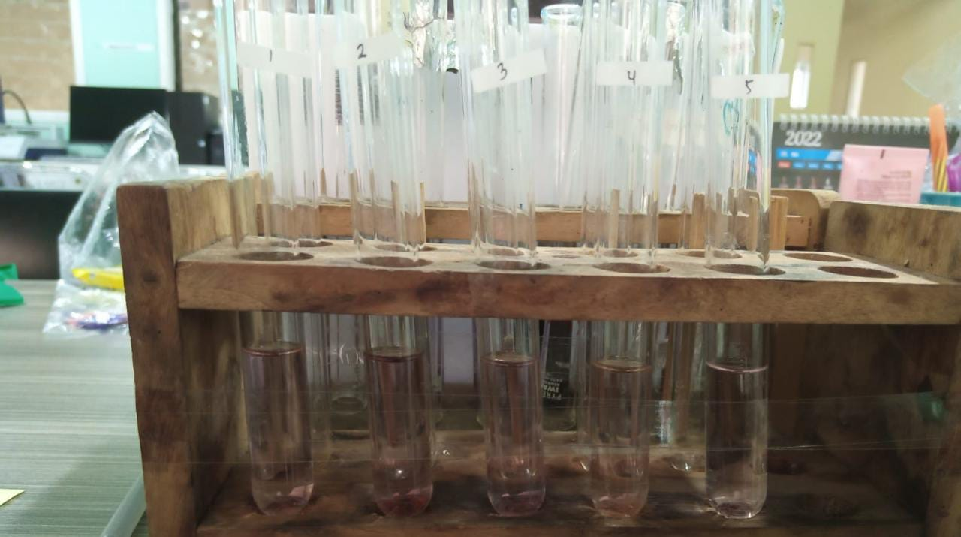

DPPH + deret Vit C
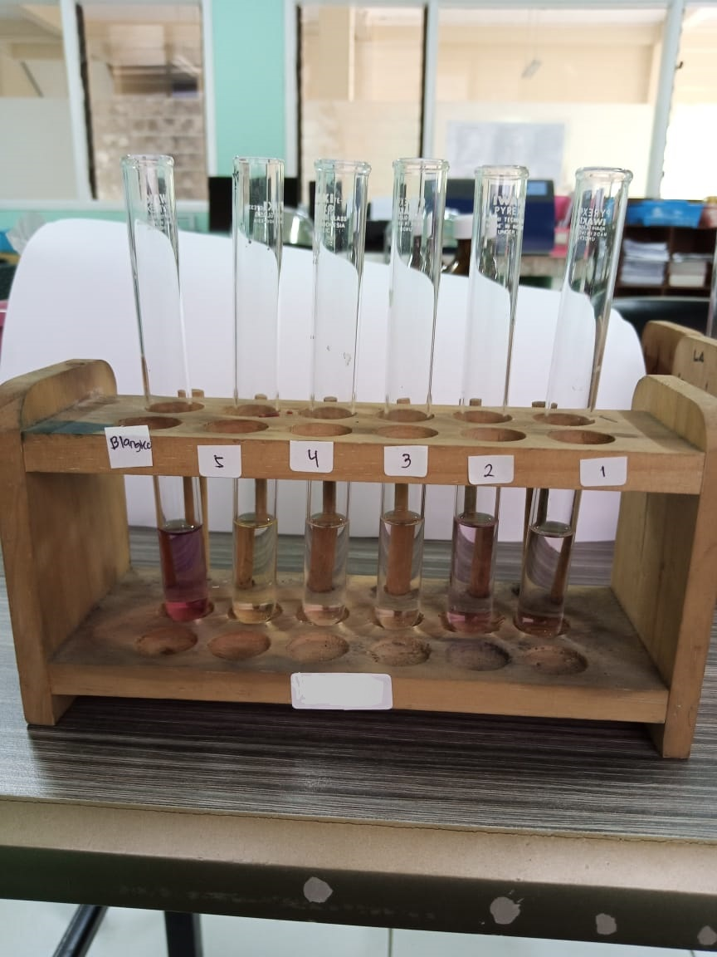

DPPH + deret MeOH
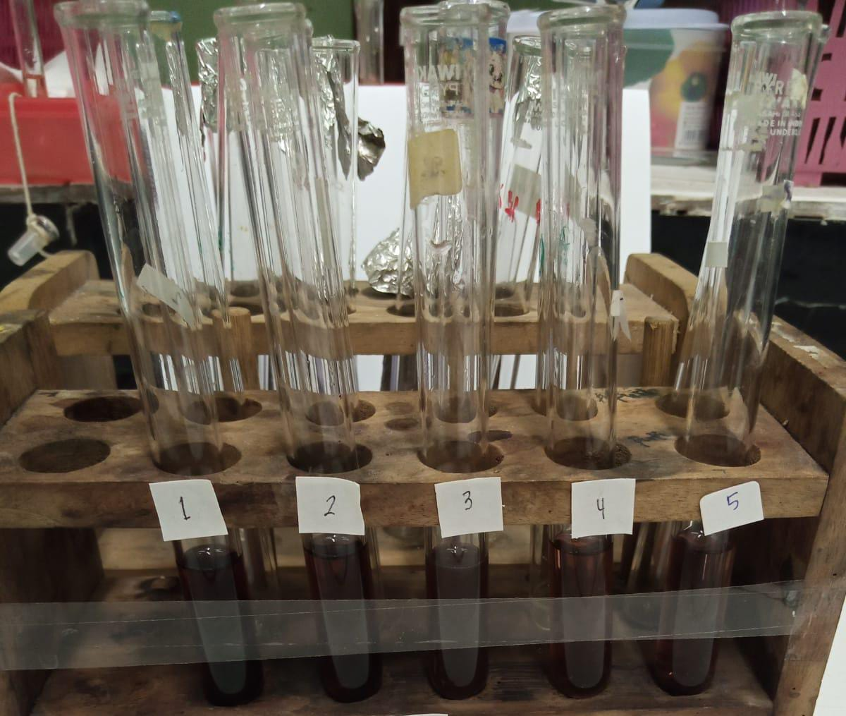

DPPH + deret Et70
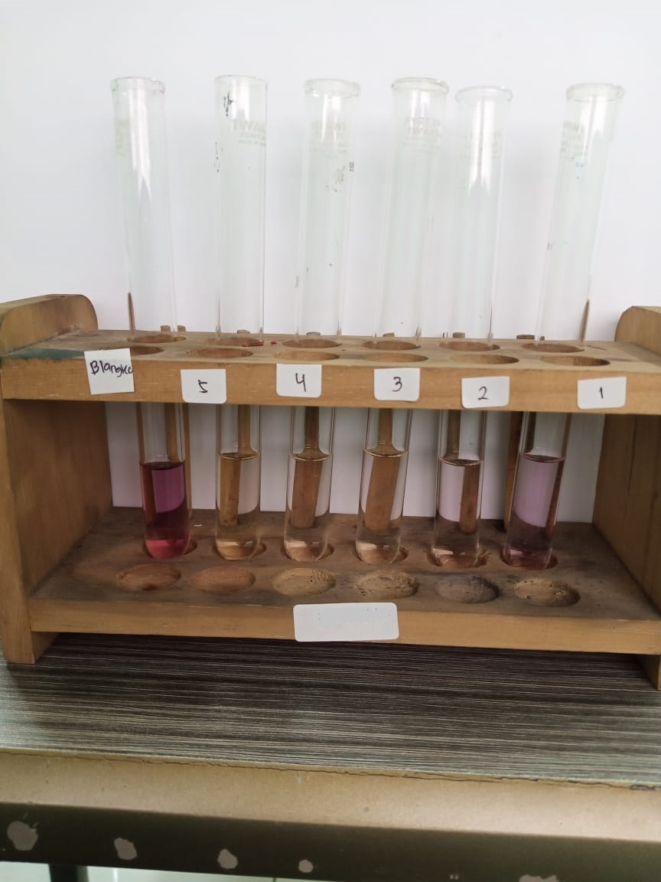

DPPH + deret Et96

Lampiran 11. Hasil Uji Antioksidan Ekstrak Daun Kawista
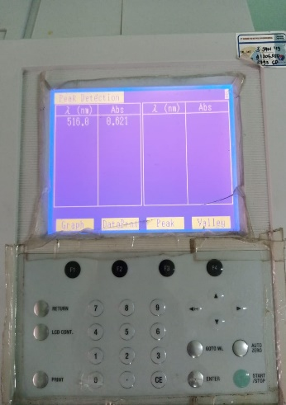λmaks | 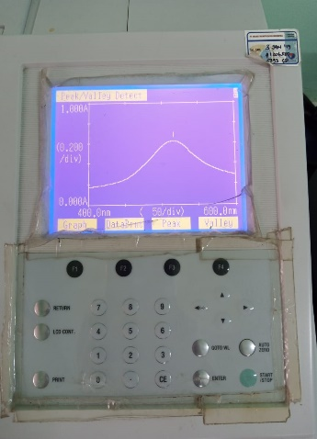  Spektrum DPPH | Hasil absorbansi
  Konsentrasi | Abs | λmaks
  100 ppm | 0,621 | 516 nm

- Antioksidan Ekstrak Metanol Daun Kawista
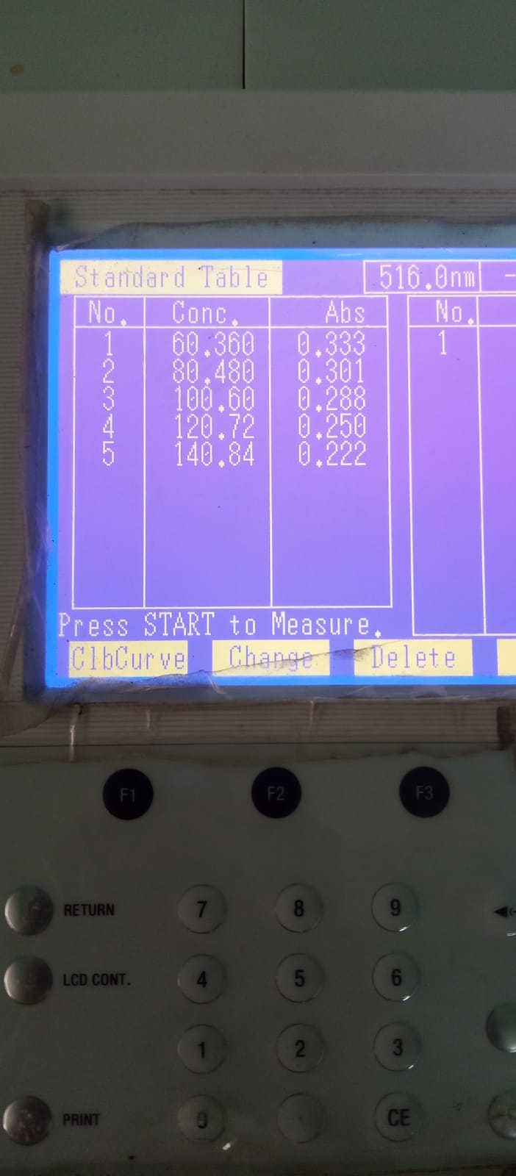  MeOH Rep I | 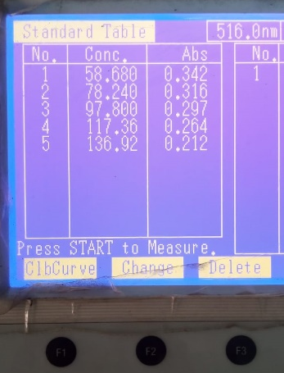  MeOH Rep II | 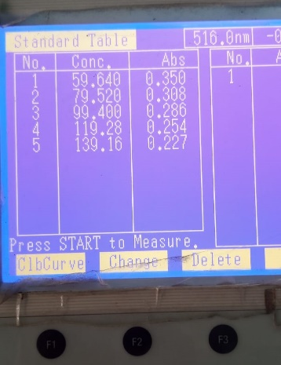  MeOH Rep III
Penimbangan Baku Induk Replikasi I :
50,3 ml ad 50 ml = 1006 ppm
P. 5kali = 201,2 ppm
Deret Konsentrasi  (V1 x C1 = V2 x C2) | Koreksi Kadar  (V1 x C1 = V2 x C2)
60 ppm  V1 x 200 ppm = 10 ml x 60 ppm  V1 = 3 ml | 60 ppm  3 ml x 201,2 ppm = 10 ml x C2  C2 = 60,36 ppm
80 ppm  V1 x 200 ppm = 25 ml x 80 ppm  V1 = 10 ml | 80 ppm  10 ml x 201,2 ppm = 25 ml x C2  C2 = 80,48 ppm
100 ppm  V1 x 200 ppm = 10 ml x 100 ppm  V1 = 5 ml | 100 ppm  5 ml x 201,2 ppm = 10 ml x C2  C2 = 100,60 ppm
120 ppm  V1 x 200 ppm = 5 ml x 120 ppm  V1 = 3 ml | 120 ppm  3 ml x 201,2 ppm = 5 ml x C2  C2 = 120,72 ppm
140 ppm  V1 x 200 ppm = 5 ml x 140 ppm  V1 = 3,5 ml | 140 ppm  3,5 ml x 201,2 ppm = 5 ml x C2  C2 = 140,84 ppm

- Persen Inhibisi DPPH dan Regresi Linier
Rumus % inhibisi = $\frac{ (Abs Kontrol-Abs Sampel)}{Abs Kontrol}$ x 100%
Replikasi | Konsentrasi Sampel (ppm)  (X) | Absorbansi Kontrol | Absorbansi Sampel | % Inhibisi  (Y) | Regresi Linier
I | 60,360 | 0,621 | 0,333 | 46,38 | a = 33,1240
I | 80,480 | 0,621 | 0,301 | 51,53 | b = 0,2185
I | 100,600 | 0,621 | 0,288 | 53,62 | r = 0,99218
I | 120,720 | 0,621 | 0,250 | 59,74 | r = 0,99218
I | 140,840 | 0,621 | 0,222 | 64,25 | r = 0,99218
II | 58,680 | 0,621 | 0,342 | 44,93 | a = 28,7930
II | 78,240 | 0,621 | 0,316 | 49,11 | b = 0,2569
II | 97,800 | 0,621 | 0,297 | 52,17 | r = 0,9809
II | 117,360 | 0,621 | 0,264 | 57,49 | r = 0,9809
II | 136,920 | 0,621 | 0,212 | 65,86 | r = 0,9809
III | 59,640 | 0,621 | 0,350 | 43,64 | a = 29,9517
III | 79,520 | 0,621 | 0,308 | 50,40 | b = 0,2430
III | 99,400 | 0,621 | 0,286 | 53,95 | r = 0,9956
III | 119,280 | 0,621 | 0,254 | 59,10 | r = 0,9956
III | 139,160 | 0,621 | 0,227 | 63,45 | r = 0,9956

- Nilai IC₅₀ dan Nilai AAI ( $\frac{ Konsentrasi DPPH (ppm)}{IC50 (ppm)}$ )
Replikasi | Persamaan Regresi Linier | Nilai IC₅₀  (ppm) | Rata – rata nilai IC₅₀  (ppm) | Nilai AAI | Rata – rata nilai AAI
I | Y = 0,2185x + 33,1240  Y diganti dengan 50 | 77,2372 | 80,7683  ± 3,0582 | 1,2947 | 1,2393  ± 0,0479
II | Y = 0,2569x + 28,7923  Y diganti dengan 50 | 82,5658 | 80,7683  ± 3,0582 | 1,2112 | 1,2393  ± 0,0479
III | Y = 0,2430x + 29,9517  Y diganti dengan 50 | 82,5020 | 80,7683  ± 3,0582 | 1,2121 | 1,2393  ± 0,0479

- Antioksidan Ekstrak Etanol 70% Daun Kawista
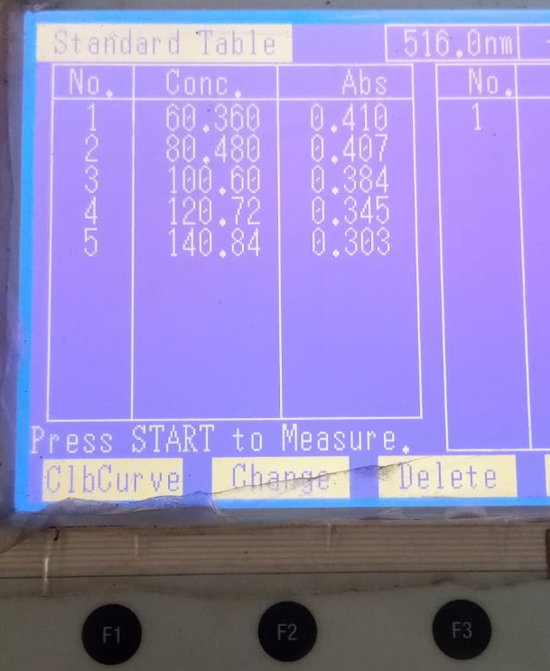  Et70 Rep I | 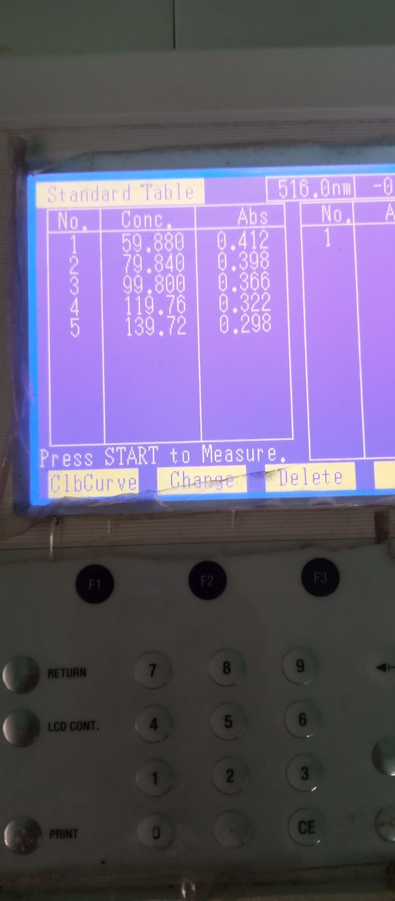  Et70 Rep II | 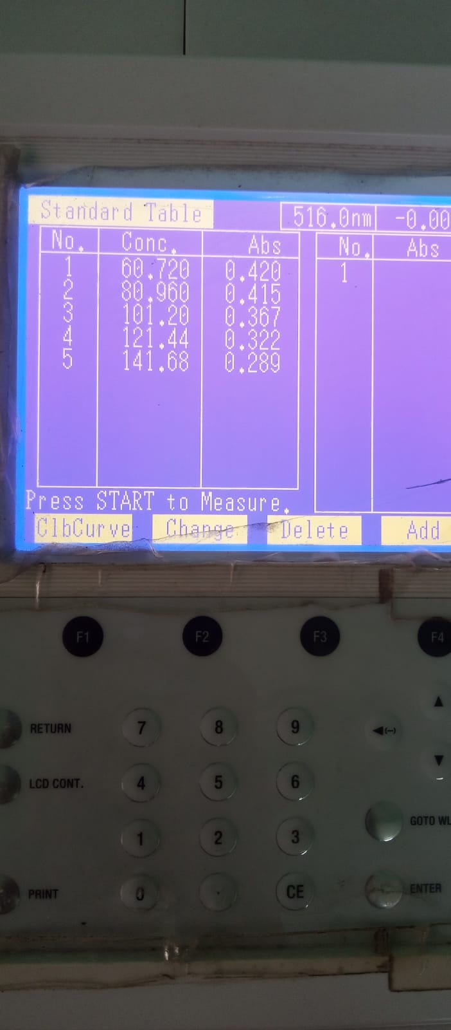  Et70 Rep III

- Persen Inhibisi DPPH dan Regresi Linier
Rumus % inhibisi = $\frac{ (Abs Kontrol-Abs Sampel)}{Abs Kontrol}$ x 100%
Replikasi | Konsentrasi Sampel (ppm)  (X) | Absorbansi Kontrol | Absorbansi Sampel | % Inhibisi  (Y) | Regresi Linier
I | 60,360 | 0,621 | 0,410 | 33,98 | a = 18,2287
I | 80,480 | 0,621 | 0,407 | 34,46 | b = 0,2209
I | 100,600 | 0,621 | 0,384 | 38,16 | r = 0,95924
I | 120,720 | 0,621 | 0,345 | 44,44 | r = 0,95924
I | 140,840 | 0,621 | 0,303 | 51,21 | r = 0,95924
II | 60,720 | 0,621 | 0,420 | 32,37 | a = 13,0274
II | 80,960 | 0,621 | 0,415 | 33,17 | b = 0,28244
II | 101,200 | 0,621 | 0,367 | 40,90 | r = 0,97989
II | 121,440 | 0,621 | 0,322 | 48,15 | r = 0,97989
II | 141,68 | 0,621 | 0,289 | 53,46 | r = 0,97989
III | 59,88 | 0,621 | 0,412 | 33,66 | a = 17,6812
III | 79,84 | 0,621 | 0,398 | 35,91 | b = 0,24526
III | 99,80 | 0,621 | 0,366 | 41,06 | r = 0,98793
III | 119,76 | 0,621 | 0,322 | 48,15 | r = 0,98793
III | 139,72 | 0,621 | 0,298 | 52,01 | r = 0,98793

- Nilai IC₅₀ dan Nilai AAI ( $\frac{ Konsentrasi DPPH (ppm)}{IC50 (ppm)}$ )
Replikasi | Persamaan Regresi Linier | Nilai IC₅₀  (ppm) | Rata – rata nilai IC₅₀  (ppm) | Nilai AAI | Rata – rata nilai AAI
I | Y = 0,2209x + 18,2287  Y diganti dengan 50 | 143,829 | 135,503 | 0,6953 | 0,7394
II | Y = 0,28244x + 13,0274  Y diganti dengan 50 | 130,904 | 135,503 | 0,7639 | 0,7394
III | Y = 0,24526x + 17,6812  Y diganti dengan 50 | 131,775 | 135,503 | 0,7589 | 0,7394

- Antioksidan Ekstrak Etanol 96% Daun Kawista
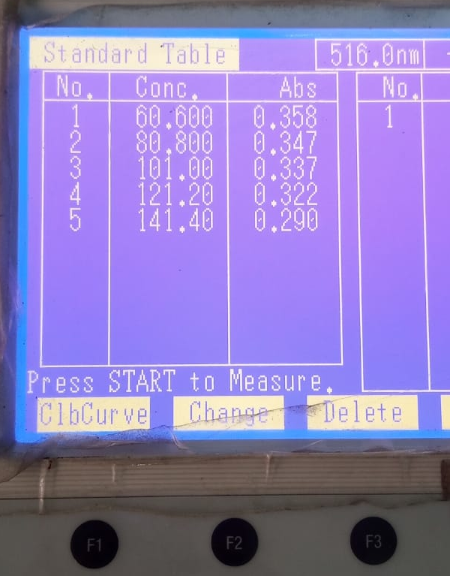  Et96 Rep I | 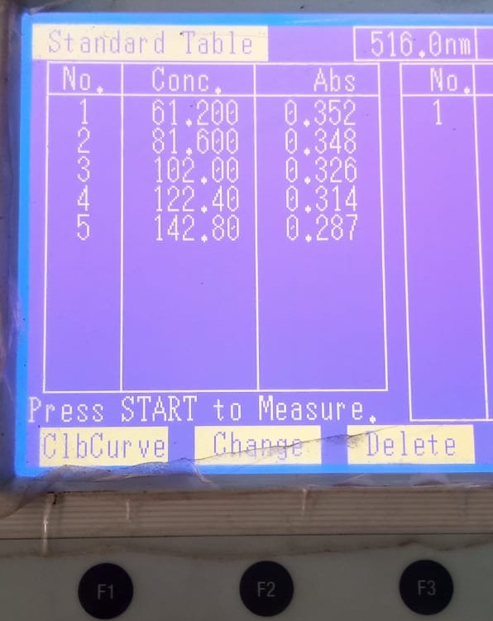  Et96 Rep II | 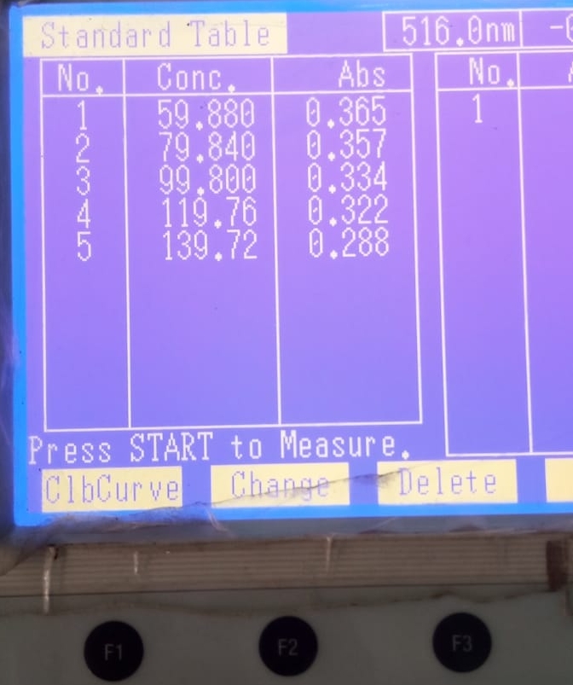  Et96 Rep III

- Persen Inhibisi DPPH dan Regresi Linier
Rumus % inhibisi = $\frac{ (Abs Kontrol-Abs Sampel)}{Abs Kontrol}$ x 100%
Replikasi | Konsentrasi Sampel (ppm)  (X) | Absorbansi Kontrol | Absorbansi Sampel | % Inhibisi  (Y) | Regresi Linier
I | 59,88 | 0,621 | 0,365 | 41,22 | a = 31,127
I | 79,84 | 0,621 | 0,357 | 42,51 | b = 0,1525
I | 99,80 | 0,621 | 0,334 | 46,22 | r = 0,9764
I | 119,76 | 0,621 | 0,322 | 48,15 | r = 0,9764
I | 139,72 | 0,621 | 0,288 | 53,62 | r = 0,9764
II | 60,60 | 0,621 | 0,358 | 42,35 | a = 33,768
II | 80,80 | 0,621 | 0,347 | 44,12 | b = 0,1283
II | 101,00 | 0,621 | 0,337 | 45,73 | r = 0,9651
II | 121,20 | 0,621 | 0,322 | 48,15 | r = 0,9651
II | 141,40 | 0,621 | 0,290 | 53,30 | r = 0,9651
III | 61,20 | 0,621 | 0,352 | 43,32 | a = 34,396
III | 81,60 | 0,621 | 0,348 | 43,96 | b = 0,1295
III | 102,00 | 0,621 | 0,326 | 47,50 | r = 0,9761
III | 122,40 | 0,621 | 0,314 | 49,44 | r = 0,9761
III | 142,80 | 0,621 | 0,287 | 53,78 | r = 0,9761

- Nilai IC₅₀ dan Nilai AAI ( $\frac{ Konsentrasi DPPH (ppm)}{IC50 (ppm)}$ )
Replikasi | Persamaan Regresi Linier | Nilai IC₅₀  (ppm) | Rata – rata nilai IC₅₀  (ppm) | Nilai AAI | Rata – rata nilai AAI
I | Y = 0,1525x + 31,127  Y diganti dengan 50 | 123,77 | 123,59 | 0,8079 | 0,8094
II | Y = 0,1283x + 33,768  Y diganti dengan 50 | 126,47 | 123,59 | 0,7907 | 0,8094
III | Y = 0,1295x + 34,396  Y diganti dengan 50 | 120,53 | 123,59 | 0,8297 | 0,8094

- Antioksidan Baku Vitamin C
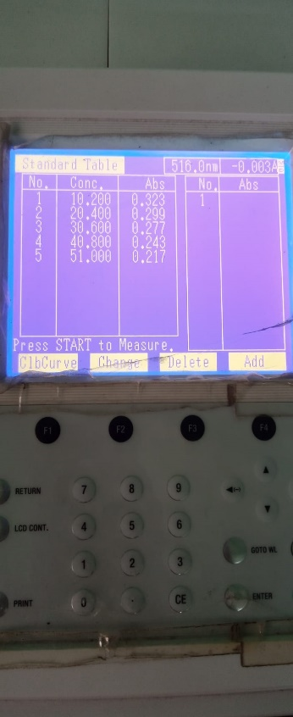  Vit C Rep I | 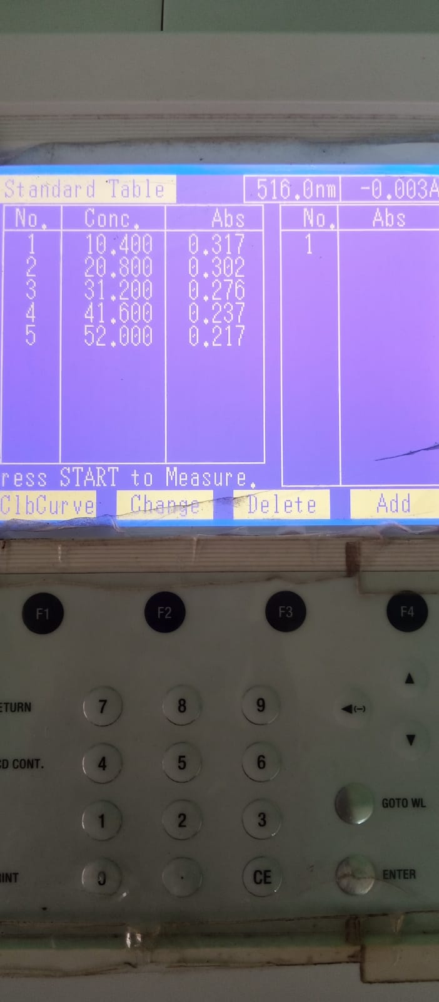  Vit C Rep II | 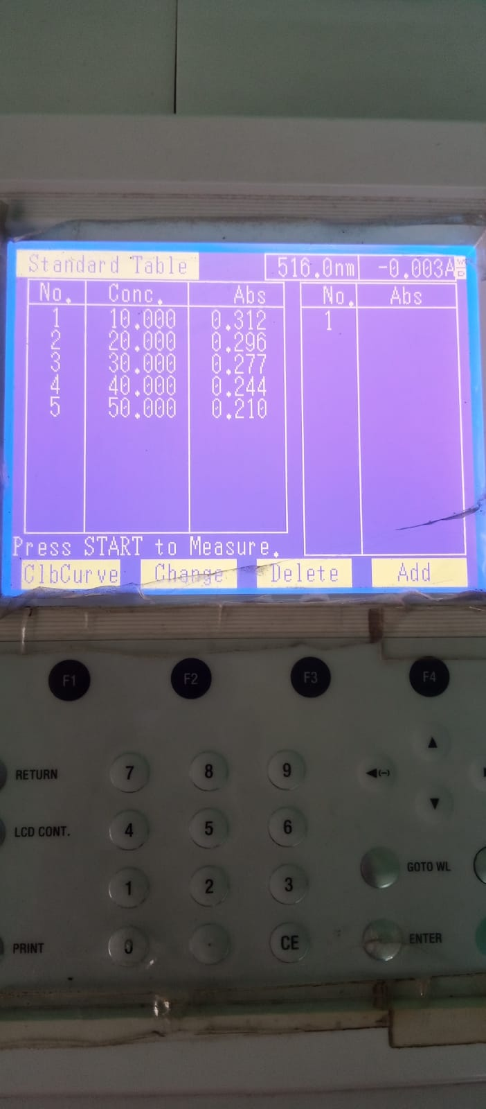  Vit C Rep III

- Persen Inhibisi DPPH dan Regresi Linier
Rumus % inhibisi = $\frac{ (Abs Kontrol-Abs Sampel)}{Abs Kontrol}$ x 100%
Replikasi | Konsentrasi Baku (ppm)  (X) | Absorbansi Kontrol | Absorbansi Baku | % Inhibisi  (Y) | Regresi Linier
I | 10,20 | 0,621 | 0,323 | 47,99 | a = 43,285
I | 20,40 | 0,621 | 0,299 | 51,85 | b = 0,4231
I | 30,60 | 0,621 | 0,277 | 55,39 | r = 0,99734
I | 40,80 | 0,621 | 0,243 | 60,87 | r = 0,99734
I | 51,00 | 0,621 | 0,217 | 65,06 | r = 0,99734
II | 10,00 | 0,621 | 0,312 | 49,76 | a = 44,5089
II | 20,00 | 0,621 | 0,296 | 52,33 | b = 0,41224
II | 30,00 | 0,621 | 0,277 | 55,39 | r = 0,98602
II | 40,00 | 0,621 | 0,244 | 60,71 | r = 0,98602
II | 50,00 | 0,621 | 0,210 | 66,18 | r = 0,98602
III | 10,40 | 0,621 | 0,317 | 48,95 | a = 43,752
III | 20,80 | 0,621 | 0,302 | 51,37 | b = 0,41032
III | 31,20 | 0,621 | 0,276 | 55,56 | r = 0,98988
III | 41,60 | 0,621 | 0,237 | 61,84 | r = 0,98988
III | 52,00 | 0,621 | 0,217 | 65,06 | r = 0,98988

- Nilai IC₅₀ dan Nilai AAI ( $\frac{ Konsentrasi DPPH (ppm)}{IC50 (ppm)}$ )
Replikasi | Persamaan Regresi Linier | Nilai IC₅₀  (ppm) | Rata – rata nilai IC₅₀  (ppm) | Nilai AAI | Rata – rata nilai AAI
I | Y = 0,4231x + 43,285  Y diganti dengan 50 | 15,8709 | 14,8061 | 6,3008 | 6,7918
II | Y = 0,41224x + 44,5089  Y diganti dengan 50 | 13,3203 | 14,8061 | 7,5073 | 6,7918
III | Y = 0,41032x + 43,752  Y diganti dengan 50 | 15,2272 | 14,8061 | 6,5672 | 6,7918

Lampiran 8. Uji Statistika Aktivitas Antioksidan Ekstrak Daun Kawista
- Data IC₅₀ dan AAI Ekstrak Daun Kawista
Kelompok | Replikasi | IC₅₀ | AAI
I  (EM) | 1 | 77,2372 | 1,2947
I  (EM) | 2 | 82,5658 | 1,2112
I  (EM) | 3 | 82,502 | 1,2121
II  (EE70) | 1 | 143,829 | 0,6953
II  (EE70) | 2 | 130,904 | 0,7639
II  (EE70) | 3 | 131,775 | 0,7589
III  (EE96) | 1 | 123,77 | 0,8079
III  (EE96) | 2 | 126,47 | 0,7907
III  (EE96) | 3 | 120,53 | 0,8297
IV  (SVC) | 1 | 15,8709 | 6,3008
IV  (SVC) | 2 | 13,3203 | 7,5073
IV  (SVC) | 3 | 15,2272 | 6,5672

- Hasil Uji Statistik Antioksidan Ekstrak Daun Kawista

Uji Normalitas

Tests of Normality
 | Kolmogorov-Smirnovª |  |  | Shapiro-Wilk
 | Statistic | df | Sig. | Statistic | df | Sig.
IC50 | .279 | 9 | .041 | .835 | 9 | .050
AAI | .330 | 9 | .005 | .783 | 9 | .013
a. Lilliefors Significance Correction

Interpretasi Hasil :
Berdasarkan tabel Test of Normality didapatkan Nilai Sig = 0,05 dan 0,013 (kurang dari α = 0,05) sehingga H0 ditolak dan data antioksidan dinyatakan tidak terdistribusi normal.
Sehingga dilanjutkan uji alternatif (non parametrik) yaitu Kruskal wallis

